

Fine-Grained Bird Species Classification using Swin Transformer with Part-Based Attention
SDP PROJECT REPORT
School of Computer Science and Engineering By
22BCE9651 -K Nichal haas 22BCE7360 -Sumanth Perugu
22BCE7919 -Devansh Chhibber

Submitted to: -

Dr Hari Kishan Kondaveeti
Department of Software and System Engineering

2025-2026

TABLE OF CONTENTS

Chapter No. | Title | Page No.
 | Abstract | 3
1 | Introduction  - Objective  - Scope &Motivation  - Organization of the Report (other related Topics)  - Dataset Overview | 4
2 | Literature Survey | 11
3 | Hardware and Software Requirements | 13
4 | Proposed Methodology  - Dataset Preparation  - Proposed Methodology Framework(Include Block Diagram) (other related Topics) | 17
5 | Results and Discussions | 28
6 | Conclusion | 34
7 | Future Work | 35
8 | Appendix I-Source Code(with corresponding output) | 37
9 | References | 59

ABSTRACT

Fine-grained visual classification remains a challenging problem in computer vision due to the subtle inter-class variations and high intra-class similarity present in real-world datasets. In particular, bird species classification requires the model to capture highly localized and discriminative features such as beak shape, wing patterns, and color distributions, which are often overlooked by conventional global feature extraction methods. Recent transformer-based architectures, such as Swin Transformers, have demonstrated strong performance by modeling long-range dependencies; however, they tend to focus on global representations and may not explicitly emphasize region-specific discriminative cues essential for fine-grained recognition.
In this work, we propose a part-based attention framework built upon a Swin Transformer backbone for fine-grained bird species classification on the CUB-200-2011 dataset. The core idea is to introduce a set of learnable part tokens that interact with image features through a cross-attention mechanism. These part tokens act as queries that attend to different spatial regions of the image, enabling the model to automatically discover and focus on informative parts such as the head, wings, tail, and body without requiring explicit part annotations. This design allows the network to learn region-aware representations while maintaining the global contextual understanding provided by the transformer backbone.
The extracted part-level features are combined with the global feature representation obtained from the transformer tokens through a feature fusion strategy. To encourage diversity among the learned parts and prevent redundancy, we incorporate a diversity constraint that minimizes the similarity between part features, ensuring that each part token captures distinct visual characteristics. The fused representation is then passed to a classification head to predict the bird species.
Extensive experiments demonstrate the effectiveness of the proposed approach. Starting from a Swin Transformer baseline, we show that the integration of part-based attention leads to consistent performance improvements. The final model achieves over 90% Top-1 classification accuracy on the CUB-200-2011 dataset when combined with test-time augmentation strategies. Through ablation studies, we observe that using four part tokens provides an optimal balance between representation capacity and redundancy, while increasing the number of parts leads to diminished returns. Furthermore, we analyze the impact of multi-scale test-time augmentation and find that it does not yield additional gains, likely due to the fixed-resolution design of the Swin architecture and the sensitivity of fine-grained features to scale variations.
To provide interpretability and validate the behavior of the proposed model, we employ Grad-CAM visualizations. The results indicate that the model consistently focuses on semantically meaningful and discriminative regions of the bird, such as the head and wings, confirming the effectiveness of the part-based attention mechanism. Unlike approaches that rely on manually annotated parts, our method remains fully annotation-free at the part level, making it more scalable and practical for real-world applications.
In summary, this work demonstrates that integrating learnable part-based cross-attention into transformer architectures significantly enhances fine-grained classification performance. The proposed framework is simple, effective, and does not require additional supervision, making it a promising direction for future research in fine-grained visual recognition tasks.

CHAPTER 1

INTRODUCTION

1. Introduction

Fine-grained visual classification (FGVC) aims to distinguish between closely related categories that exhibit subtle visual differences, such as bird species, car models, or plant types. Unlike coarse-grained classification, where inter-class variations are large and easily separable, FGVC requires the model to capture highly localized and discriminative features. In the case of bird species classification, these differences often manifest in fine details such as beak shape, feather texture, wing patterns, and color variations. At the same time, significant intra-class variations caused by pose, illumination, and background clutter further increase the complexity of the task.

Traditional convolutional neural networks (CNNs) have achieved strong performance in general image classification; however, they often struggle in fine-grained scenarios due to their tendency to focus on global features rather than localized discriminative regions. To address this limitation, prior works have explored part-based models and attention mechanisms that explicitly or implicitly localize informative regions. While effective, many of these approaches rely on additional supervision such as part annotations or bounding boxes, which limits their scalability and applicability to real-world datasets.

Recent advances in Vision Transformers (ViTs) and hierarchical transformer architectures, such as Swin Transformers, have demonstrated superior performance by modeling long-range dependencies and capturing global contextual information. However, despite their strong representational power, these models do not explicitly enforce region-specific attention and may overlook subtle local cues that are critical for fine-grained recognition. As a result, there remains a gap between global feature modeling and localized discriminative learning.

In this work, we address this challenge by proposing a part-based attention framework integrated with a Swin Transformer backbone. The key idea is to introduce a set of learnable part tokens that interact with image feature tokens through a cross-attention mechanism. These part tokens act as adaptive queries that attend to different spatial regions of the image, enabling the model to automatically discover and focus on discriminative parts without requiring explicit part-level annotations. This design bridges the gap between global contextual modeling and local feature specialization.

To effectively combine global and local representations, we fuse the global feature obtained from the transformer with the part-based features extracted through cross-attention. Additionally, we incorporate a diversity constraint that encourages different part tokens to capture distinct visual regions, thereby reducing redundancy and improving feature richness. Unlike prior part-based approaches, our method remains fully annotation-free at the part level, making it both efficient and scalable.

We evaluate the proposed approach on the CUB-200-2011 dataset, a standard benchmark for fine-grained bird classification. Experimental results show that integrating part-based attention into a Swin Transformer significantly improves classification performance over the baseline. We further conduct ablation studies to analyze the impact of the number of part tokens and test-time augmentation strategies. Our findings indicate that a moderate number of part tokens yields optimal performance, while excessive partitioning leads to redundancy and degraded results.
In summary, the contributions of this work are as follows:
1. We propose a learnable part-token cross-attention mechanism for fine-grained classification that does not require explicit part annotations.
2. We demonstrate how integrating part-based attention with a transformer backbone improves discriminative feature learning.
3. We provide extensive experimental analysis, including ablation studies and visualization, to validate the effectiveness of the proposed method.

4. The proposed framework offers a simple yet effective solution for enhancing fine-grained recognition and provides insights into combining global and local feature representations in transformer-based models

1.1 Objective:
The primary objective of this work is to develop an effective and scalable framework for fine-grained bird species classification by leveraging transformer-based architectures enhanced with part-based attention mechanisms. Specifically, the goal is to improve the model’s ability to distinguish between visually similar classes by capturing subtle and localized discriminative features such as beak shape, wing patterns, and color variations.

To achieve this, we aim to design a model that integrates a Swin Transformer backbone with a learnable part-token cross-attention module, enabling the network to automatically focus on informative regions of the image without relying on explicit part annotations. This approach seeks to bridge the gap between global contextual understanding and local feature discrimination, which is critical for fine-grained visual recognition tasks.
Additionally, the proposed framework aims to:
• Enhance classification accuracy beyond standard transformer baselines
• Learn diverse and non-overlapping part representations through a diversity constraint
• Maintain computational efficiency while improving interpretability
• Provide visual explanations of model behavior using techniques such as Grad-CAM
Ultimately, the objective is to demonstrate that incorporating learnable part-based attention into transformer architectures can significantly improve fine-grained classification performance while remaining annotation-free and adaptable to real-world applications.

1.2 Key Objectives of the Proposed Workflow

The proposed workflow is designed to address the challenges of fine-grained bird species classification by combining global contextual understanding with localized discriminative feature extraction. The key objectives of the workflow are outlined as follows:

1. Accurate Fine-Grained Classification
To develop a robust model capable of distinguishing between visually similar bird species by capturing subtle differences in appearance, such as texture, shape, and color patterns.

2. Integration of Transformer-Based Architecture
To leverage the strengths of the Swin Transformer in modeling long-range dependencies and hierarchical feature representations for improved visual understanding.

3. Learning Discriminative Local Features
To incorporate a part-based attention mechanism that enables the model to focus on important regions of the image, such as the head, wings, and tail, without requiring explicit part annotations.

4. Part Diversity and Feature Separation
To ensure that different part tokens capture distinct and non-overlapping information by introducing a diversity constraint, thereby reducing redundancy in learned representations.

5. Fusion of Global and Local Representations
To combine global contextual features with part-based features in order to enhance the overall discriminative power of the model.

6. Improved Generalization through Augmentation
To apply advanced data augmentation techniques, including Mixup, CutMix, and RandAugment, to improve model robustness and reduce overfitting.

7. Robust Inference via Test-Time Augmentation (TTA)
To enhance prediction stability and accuracy by aggregating outputs from multiple augmented versions of the input image during inference.

8. Model Interpretability and Visualization
To analyze and validate model behavior using visualization techniques such as Grad-CAM, ensuring that predictions are based on meaningful image regions.

9. Annotation-Free Part Learning
To eliminate dependency on manual part annotations by enabling the model to automatically learn relevant regions through attention mechanisms.

10. Scalability and Practical Applicability
To design a framework that is efficient, scalable, and adaptable to other fine-grained classification tasks beyond bird species recognition
1.3 Scope & Motivation Scope
Scope :
1.This work focuses on fine-grained bird species classification using the CUB-200-2011 dataset.
2.It employs a Swin Transformer backbone combined with a part-based attention mechanism.
3.The approach captures both global context and local discriminative features.
4.It operates without using explicit part annotations, ensuring scalability.
5.The study is limited to classification performance and does not cover real-time deployment.

Motivation:
1.Fine-grained classification is challenging due to subtle differences between classes.
2.Traditional models often fail to capture localized discriminative features effectively.
3.Transformer models capture global context but lack explicit region-focused attention.
4.This motivates the integration of part-based attention for better feature learning.
5.The goal is to improve accuracy, interpretability, and scalability without extra annotations.

1.4 Dataset Overview
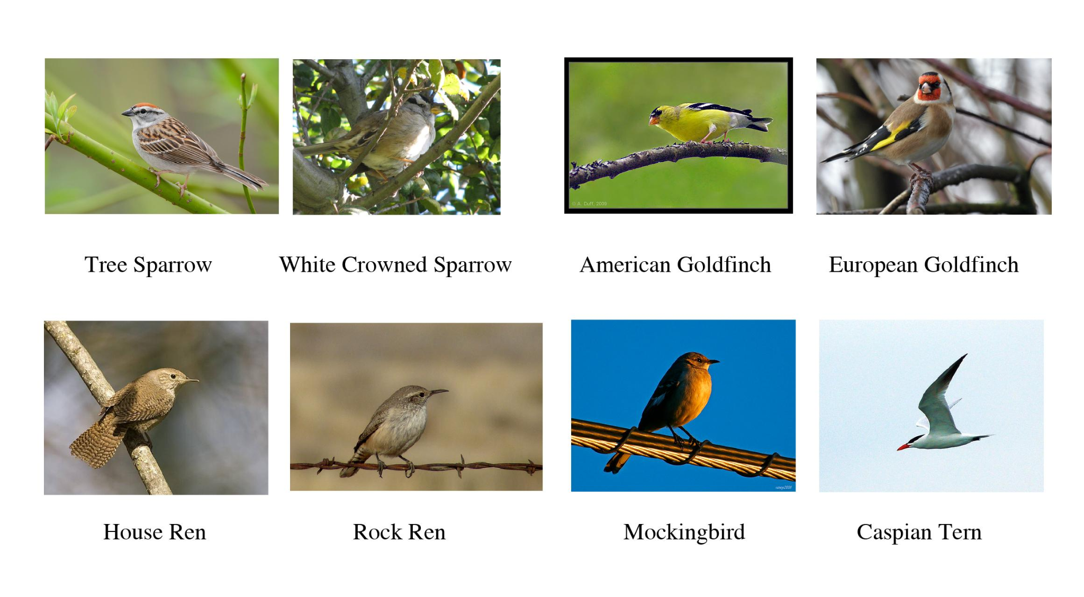

The proposed work utilizes the CUB-200-2011 (Caltech-UCSD Birds 200-2011) dataset, which is a widely recognized benchmark for fine-grained image classification tasks in computer vision research. This dataset is specifically designed to evaluate models on their ability to distinguish between visually similar subcategories.
The dataset contains a total of 11,788 images, which are categorized into 200 different bird species. Each class represents a distinct bird species characterized by subtle visual differences, making the classification task highly challenging.
One of the primary challenges of this dataset is the presence of high inter-class similarity, where different species share very similar visual features. Additionally, intra-class variations such as differences in pose, lighting conditions, background clutter, and scale further increase the complexity of the task.
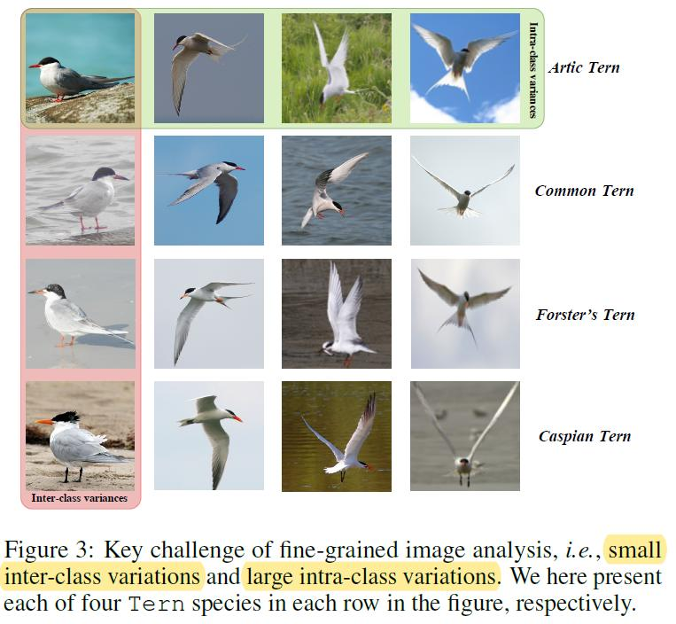
Each image in the dataset is annotated with class labels, enabling supervised learning. In addition, bounding box annotations are provided, which are used in this work to extract the region of interest by cropping the bird from the background. This preprocessing step helps in reducing noise and improving feature extraction efficiency.
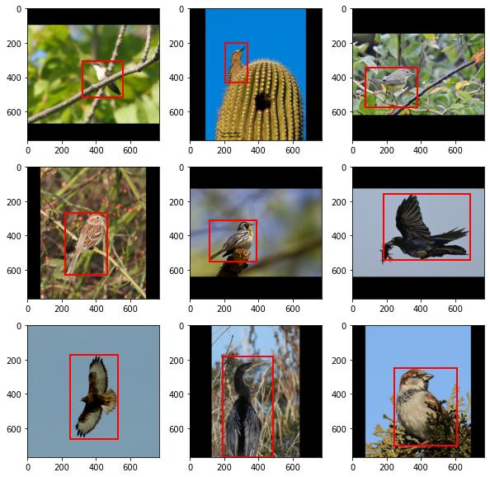
Although the dataset also provides part-level annotations (such as head, wings, and tail), these are not utilized in the proposed approach. Instead, the model learns to identify discriminative regions automatically through the part-based attention mechanism, making the framework annotation-free at the part level.
The dataset is divided into training and testing sets, where the training set is used to learn model parameters, and the testing set is used to evaluate performance. To improve generalization and robustness, various data augmentation techniques are applied, including random cropping, horizontal flipping, and other transformations.
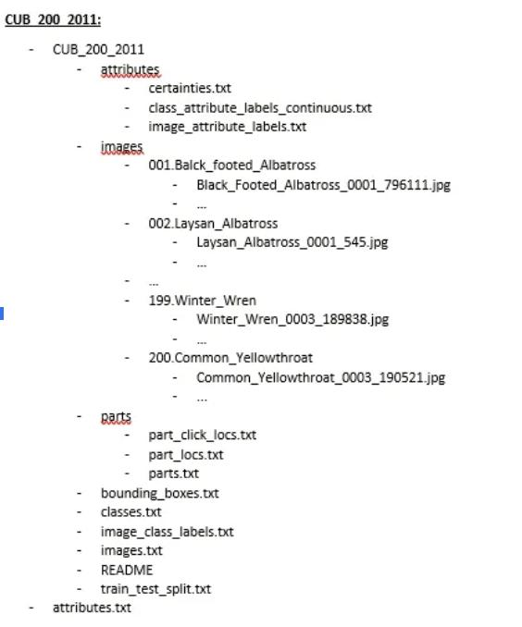
Overall, the CUB-200-2011 dataset provides a strong and challenging benchmark for evaluating fine-grained classification models, particularly those that rely on part-based attention mechanisms and discriminative feature learning.

Chapter 2
Literature Survey
Fine-grained visual classification (FGVC) focuses on distinguishing between closely related categories that exhibit subtle visual differences. This problem is particularly challenging in bird species classification, where inter-class variations are minimal and intra-class variations such as pose, illumination, and background clutter are significant.
Early approaches to image classification primarily relied on Convolutional Neural Networks (CNNs), which demonstrated strong performance in general object recognition tasks. However, CNN-based models often struggle in fine-grained classification because they tend to focus on global features rather than localized discriminative regions such as the head, wings, and tail of birds.
To address this limitation, part-based methods were introduced. One of the notable works is Part-Based R-CNNs for Fine-Grained Category Detection, which focuses on detecting specific object parts to improve classification accuracy. Although these approaches enhance performance by localizing important regions, they require manually annotated part labels, making them less scalable and more labor-intensive.
With the advancement of deep learning, attention mechanisms were incorporated into CNN architectures to enable models to focus on informative regions automatically. While attention-based CNNs improved performance, they still faced limitations in capturing long-range dependencies and global contextual relationships within images.
The introduction of transformer-based models marked a significant shift in computer vision. The Vision Transformer (ViT) demonstrated that self-attention mechanisms can effectively model global relationships between image patches, leading to improved classification performance. However, ViT lacks hierarchical feature representation and may not efficiently capture multi-scale information.
To overcome these challenges, the Swin Transformer: Hierarchical Vision Transformer using Shifted Windows was proposed. The Swin Transformer introduces a hierarchical architecture with shifted window-based self-attention, enabling efficient computation while preserving both local and global contextual information. This makes it well-suited for fine-grained visual recognition tasks.
Despite these advancements, transformer-based models primarily emphasize global feature representation and may not explicitly focus on highly discriminative local regions required for fine-grained classification. Therefore, recent research has explored integrating part-based attention mechanisms with transformer architectures to combine global contextual understanding with localized feature learning.

Research Gap
From the existing literature, the following limitations are identified:
- CNN-based models fail to capture subtle local features effectively
- Part-based approaches depend on manual annotations
- Transformer models focus on global features but lack explicit part localization
- Limited integration of global and local feature learning

Proposed Direction
To address these challenges, the proposed work introduces a hybrid approach that combines:
- Swin Transformer for hierarchical global feature extraction
- Part-Based Attention Mechanism for learning discriminative local features
- Annotation-free part learning using learnable part tokens
- Feature fusion strategy to integrate global and local representations
This approach aims to improve classification accuracy, enhance interpretability, and eliminate the need for manual part annotations, making it more scalable and effective for fine-grained visual recognition tasks.

Chapter 3

Hardware and Software Requirements

3.1 Hardware Requirements

Deep learning models for fine-grained bird species classification using transformer-based architectures are computationally intensive. Efficient training and inference require appropriate hardware resources to handle large-scale image data and attention-based computations.

3.1.1 Processor (CPU)

A multi-core processor is required to efficiently manage data preprocessing and training workflows.

Intel Core i7 / i9 or higher

AMD Ryzen 7 / Ryzen 9 or equivalent

Role:

Data loading and preprocessing

Image augmentation operations

Training pipeline coordination

3.1.2 Graphics Processing Unit (GPU)

A high-performance GPU is essential for accelerating transformer-based model training.

Minimum: NVIDIA T4 / RTX 3060

Recommended: NVIDIA A100 / RTX 3080 / RTX 4090

Minimum VRAM: 8 GB

Role:

Training the Swin Transformer backbone

Performing cross-attention computations

Accelerating backpropagation

Implementation Detail:
Training for this project was performed using an NVIDIA A100 GPU, enabling faster convergence and efficient handling of high-resolution inputs.

3.1.3 RAM

Adequate system memory is required to support dataset handling and training processes.

Minimum: 16 GB

Recommended: 32 GB or higher

Required for:

Loading the CUB-200-2011 dataset (~11,788 images)

Batch processing during training

Data augmentation pipelines

3.1.4 Storage

Sufficient storage is required for datasets, pretrained weights, and model checkpoints.

Minimum: 50–100 GB free space

Recommended: SSD (Solid State Drive)

Required for:

Dataset storage (CUB-200-2011)

Model checkpoints and logs

Pretrained Swin Transformer weights (~1–2 GB)

Advantage of SSD:

Faster data loading

Reduced I/O bottlenecks during training

3.1.5 Internet Connectivity

A stable internet connection is required for:

Downloading datasets and pretrained models

Installing dependencies and libraries

Accessing cloud platforms (Google Colab, Kaggle)

3.2 Software Requirements

A robust software environment is essential for implementing transformer-based fine-grained classification systems.

3.2.1 Operating System

The system can be implemented on:

Windows 10 / 11

Linux (Ubuntu 20.04 or later) — Recommended

macOS (limited GPU support)

Note: Linux is preferred due to better compatibility with CUDA and deep learning frameworks.

3.2.2 Programming Language

Python 3.8 or higher

Used for:

Model development

Data preprocessing

Training and evaluation

3.2.3 Development Environment

Google Colab (GPU-based experimentation)

Kaggle Notebooks (dataset + GPU integration)

VS Code / PyCharm (local development)

3.2.4 Deep Learning Libraries
Library | Purpose
PyTorch | Core deep learning framework
timm | Swin Transformer implementation
torchvision | Image transformations and dataset handling

3.2.5 Supporting Libraries
Library | Purpose
NumPy | Numerical computations
OpenCV | Image processing
Matplotlib | Visualization of results
Seaborn | Confusion matrix visualization
Scikit-learn | Evaluation metrics

3.2.6 Model & Pipeline Requirements

The proposed system consists of the following components:

Swin Transformer (Large variant, 384 resolution) for global feature extraction

Part-Based Cross-Attention Module for learning discriminative local features

Feature Fusion Layer combining global and local representations

Softmax Classifier for final prediction

Training Configuration:

Optimizer: AdamW

Learning Rate Scheduler: Cosine Annealing

Loss Function: Cross-Entropy Loss

Mixed Precision Training (AMP) for efficiency

3.2.7 Version Control and Deployment Tools

Git

GitHub

Used for:

Code version control

Experiment tracking

Collaboration and project sharing

Chapter 4

Proposed Methodology

4.1 Overview of the Proposed Framework
The proposed methodology aims to improve fine-grained bird species classification by combining global contextual feature extraction with localized discriminative feature learning.
The framework integrates:
- A Swin Transformer backbone for hierarchical global feature extraction
- A Part-Based Cross-Attention Module for learning discriminative local regions
- A Feature Fusion mechanism to combine global and local representations
This design enables the model to capture subtle visual differences between bird species without relying on explicit part annotations.

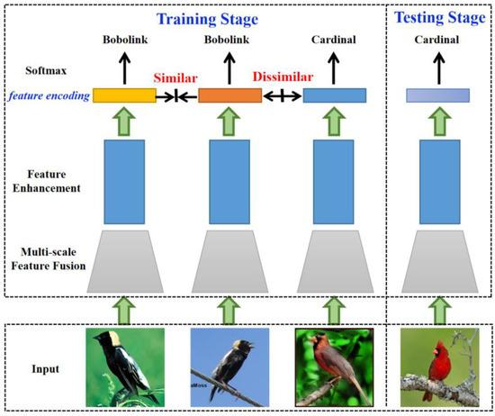
4.2 Proposed Methodology Framework
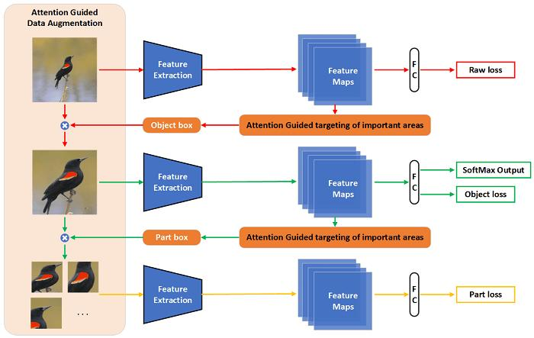
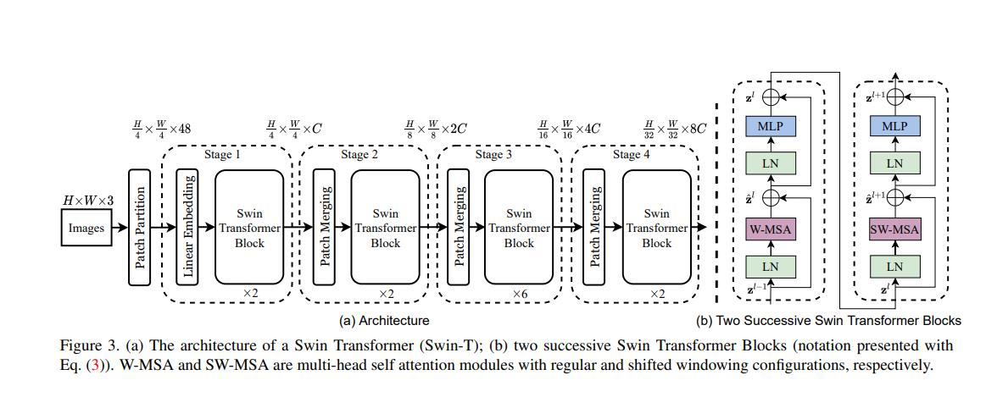
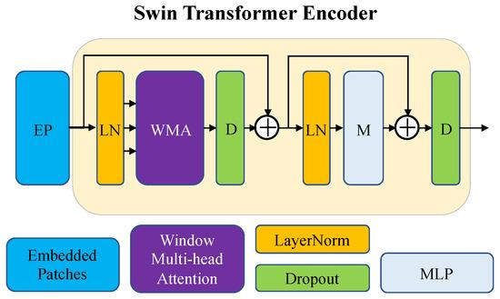

Pipeline Flow:

Input Image
↓
Preprocessing (Resize, Normalize, Augment)
↓
Swin Transformer Backbone
↓
Feature Tokens (Global Representation)
↓
Part-Based Cross-Attention Module
↓
Part Feature Extraction
↓
Feature Fusion (Global + Local)
↓
Fully Connected Layer
↓
Softmax Classifier
↓
Predicted Bird Species

4.3 Dataset Preparation
The CUB-200-2011 dataset is used for training and evaluation.

Preprocessing Steps
The following preprocessing operations are applied to the input images:
- Bounding Box Cropping:
The provided bounding box annotations are used to crop the region of interest, removing background noise and focusing on the bird.
- Image Resizing:
All images are resized to a fixed resolution of 384 × 384 pixels to match the input requirements of the Swin Transformer.
- Normalization:
Pixel values are normalized using standard ImageNet mean and standard deviation, ensuring stable training and faster convergence.
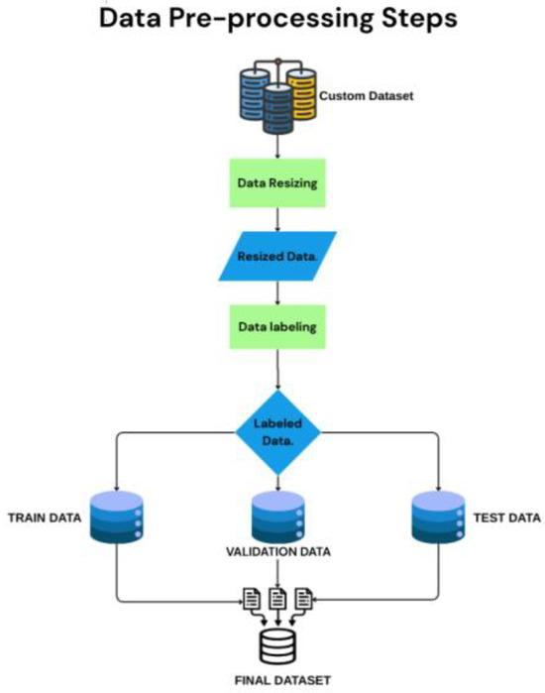
i.e:In this Project the dataset is divided into train and test.

Data Augmentation:
- Random cropping
- Horizontal flipping
- Color jittering
- Mixup and CutMix (for regularization)
These techniques improve generalization and reduce overfitting.

4.4 Swin Transformer Backbone
SWIN VS VIT
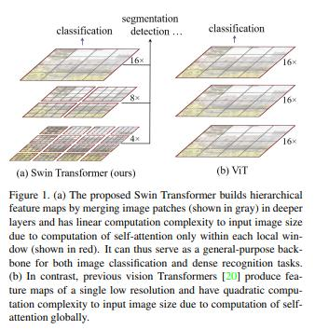

The Swin Transformer is used as the primary feature extractor due to its ability to model both local and global dependencies efficiently.

Key Features:
- Hierarchical Architecture
Builds multi-scale feature representations
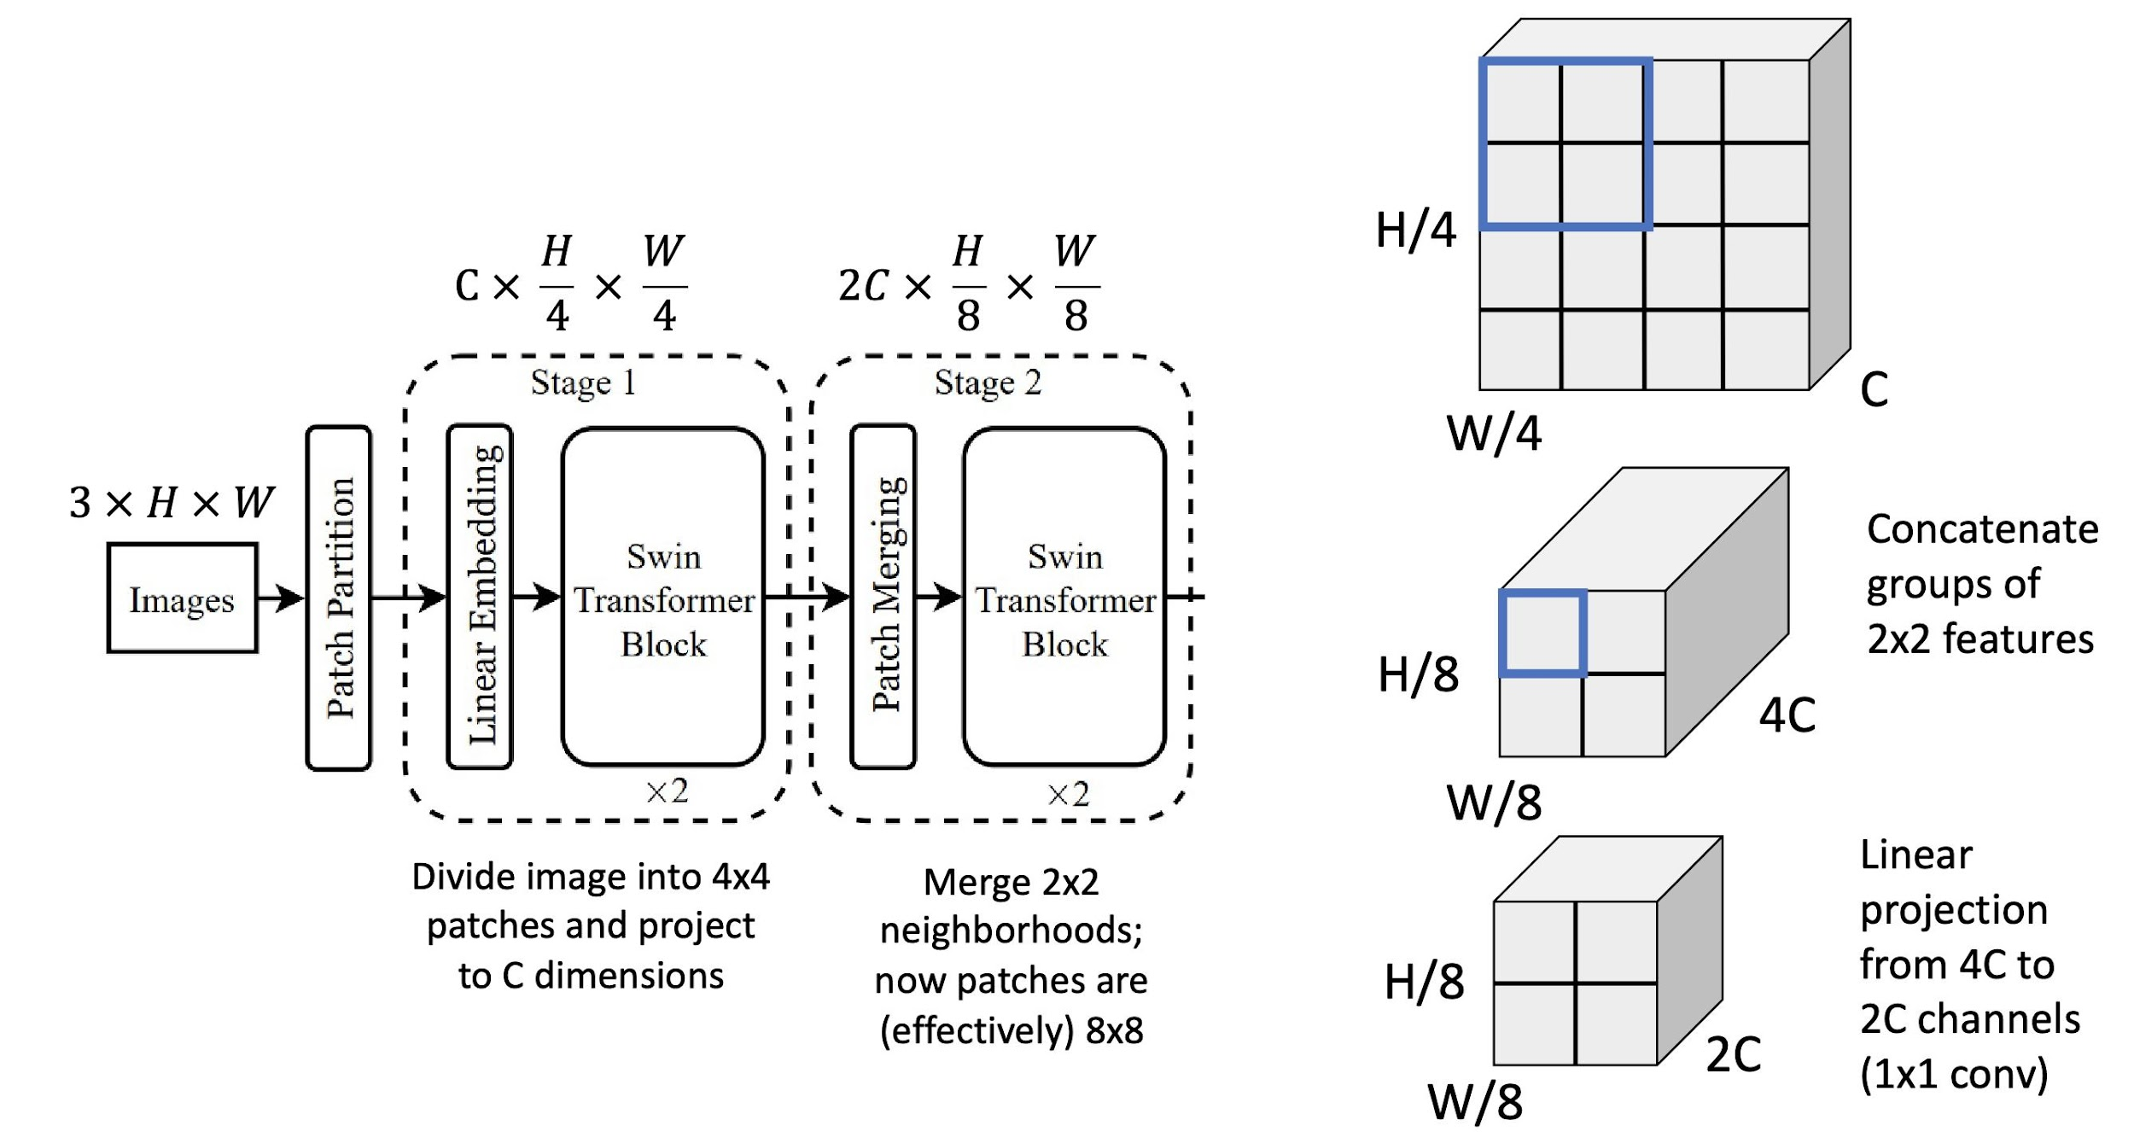
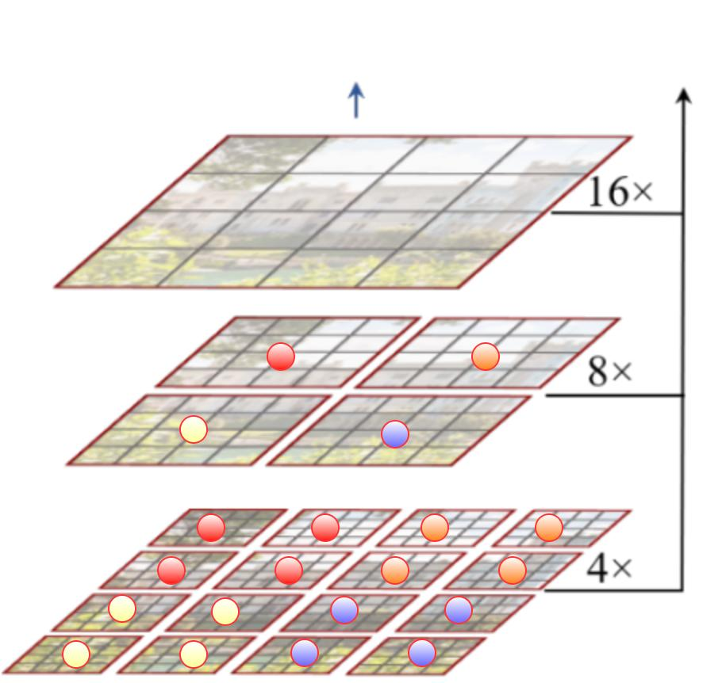
- Window-based Self-Attention
Computes attention within local windows
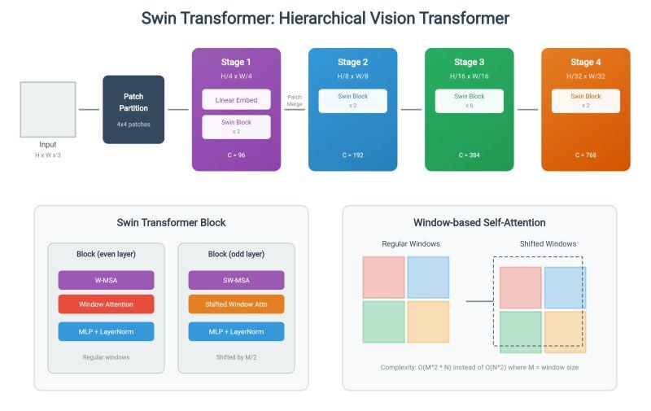
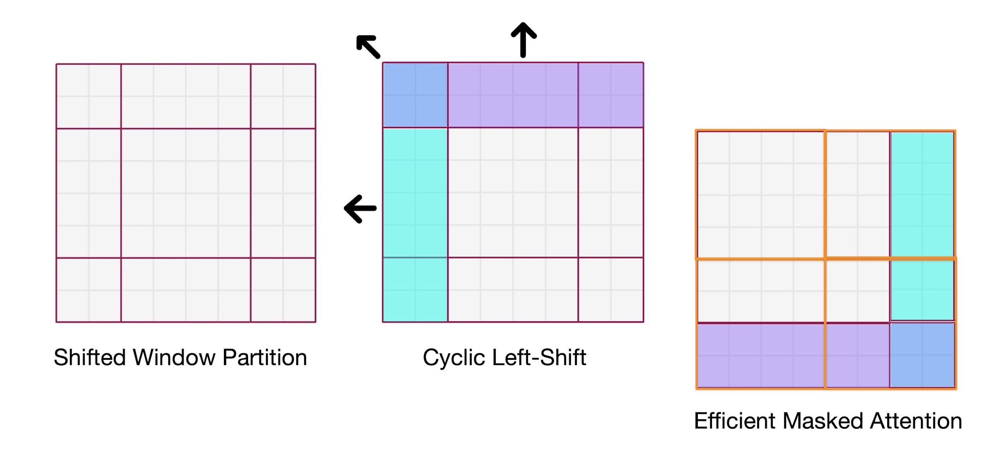
- Shifted Window Mechanism
Enables cross-window information exchange

Output:
The backbone produces a set of feature tokens representing global image information.

4.5 Part-Based Cross-Attention Module

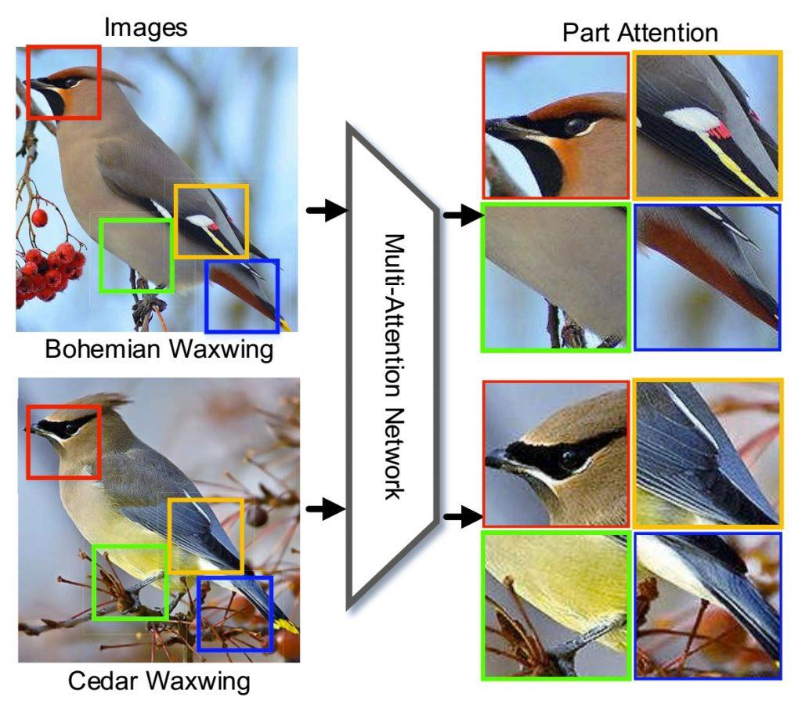


To capture fine-grained details, a Part-Based Attention Mechanism is introduced.

Core Idea:
- Introduce learnable part tokens
- Each token attends to different image regions
- No manual annotations required
How It Works:
- Feature tokens from Swin → act as keys & values
- Part tokens → act as queries
- Cross-attention computes:
Which region each part should focus on
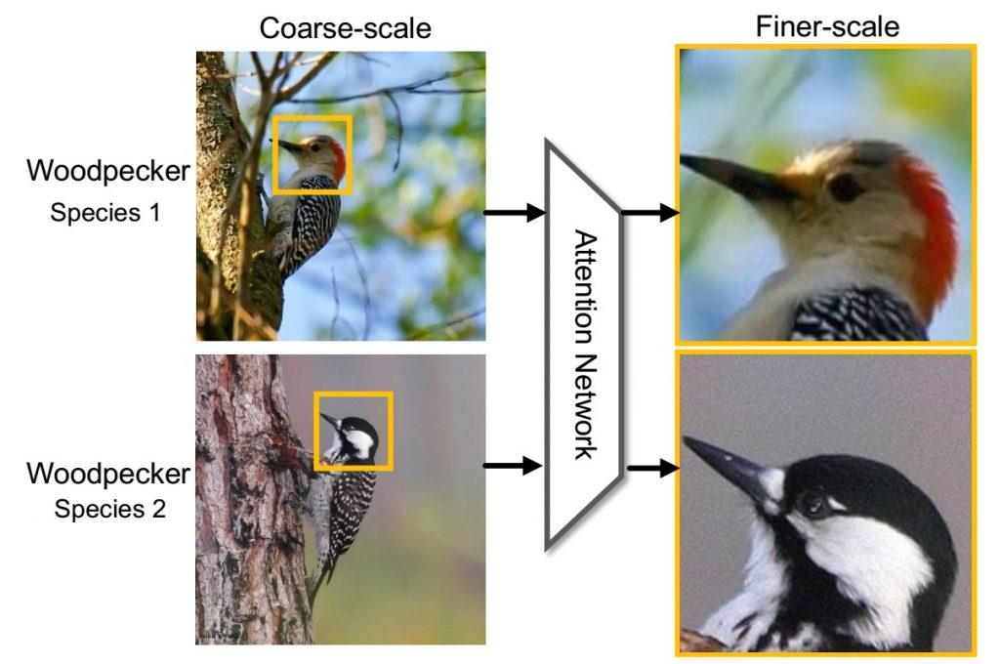

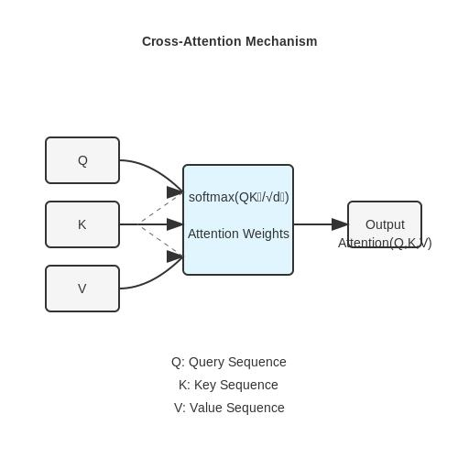
Mathematical Intuition:
Cross-attention is computed as:
Attention(Q, K, V) = Softmax(QKᵀ / √d) V

Where:
- Q → Part tokens
- K, V → Image feature tokens

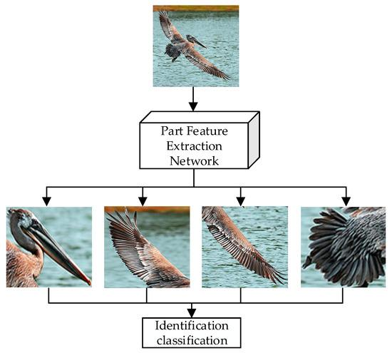
Output:
- Each part token captures a distinct region
  - Head
  - Wings
  - Tail
  - Body

4.6 Diversity Constraint
A key challenge is preventing multiple part tokens from focusing on the same region.

Solution: Diversity Loss
- Encourages different part tokens to learn different features
- Reduces redundancy
Idea:
- Minimize similarity between part features

Benefit:
- Improves feature richness
- Enhances classification performance
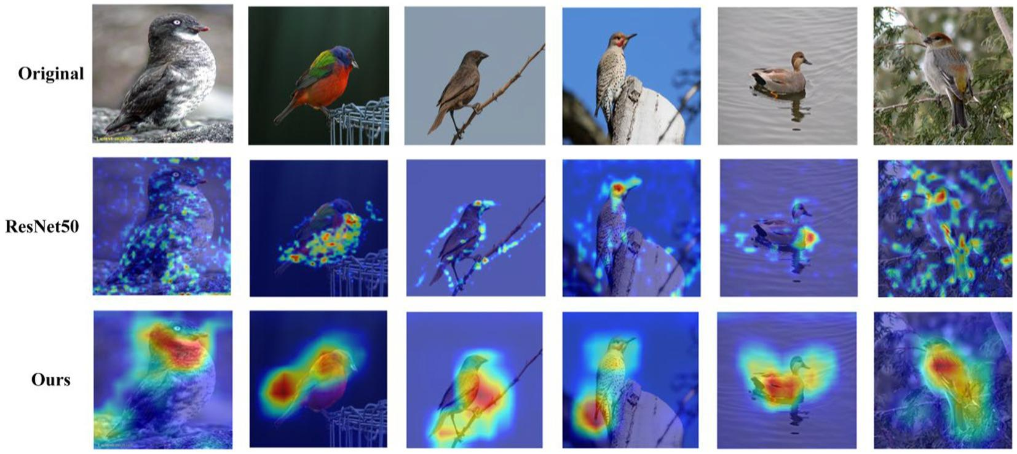

4.7 Feature Fusion
The model combines:
- Global features (from Swin Transformer)
- Local part features (from attention module)

Method:
- Concatenation of features
- Followed by fully connected layer
This creates a richer representation for classification.

4.8 Classification Layer
- Fully Connected Layer
- Softmax activation

Output:
- Probability distribution over 200 bird species

4.9 Training Strategy
The proposed model is trained using a combination of optimization techniques and regularization strategies to ensure stable convergence and improved generalization performance.

Loss Function
The model is optimized using the Cross-Entropy Loss, which measures the difference between predicted class probabilities and ground truth labels. This loss function is suitable for multi-class classification tasks such as bird species recognition.

Optimization
The AdamW optimizer is used for training. It decouples weight decay from gradient updates, which improves generalization and prevents overfitting, especially in transformer-based models.

Learning Rate Scheduling
A cosine annealing learning rate scheduler is applied to gradually decrease the learning rate during training. This helps achieve smoother convergence and avoids sudden parameter updates in later stages.

Regularization Techniques
To improve robustness and prevent overfitting, the following techniques are applied:
- Mixup: Combines pairs of images and labels to generate interpolated samples
- CutMix: Replaces regions of an image with patches from another image, improving localization capability
- Data Augmentation: Includes random cropping, horizontal flipping, and color transformations

Training Enhancements
To improve computational efficiency and numerical stability:
- Mixed Precision Training (AMP) is used to accelerate training and reduce memory usage
- Gradient scaling is applied to prevent numerical instability during backpropagation

Summary
These strategies collectively improve training stability, enhance generalization, and enable efficient learning of fine-grained features in the proposed model.

4.10 Inference Strategy
During inference, Test-Time Augmentation (TTA) is used to improve prediction robustness and accuracy.

Methodology
Multiple augmented versions of the input image, such as horizontal flips and slight spatial transformations, are generated. Each augmented image is passed through the model independently.
The final prediction is obtained by averaging the output probabilities from all augmented inputs.

Benefits
- Improves prediction stability by reducing sensitivity to input variations
- Enhances generalization performance
- Provides higher accuracy compared to single-pass inference

4.11 Test-Time Augmentation (TTA)
To improve prediction robustness during inference, Test-Time Augmentation (TTA) is employed.

Methodology
During testing, multiple augmented versions of the same input image are generated. These transformations include:
- Horizontal flipping
- Minor spatial variations (cropping or scaling)
Each augmented image is passed independently through the trained model. The final prediction is obtained by averaging the output probabilities across all augmented inputs.

Mathematical Representation
If ​ p(final) represents the prediction probability from the ithi^{th}ith augmented input, the final prediction is computed as:
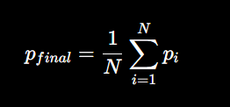
where N is the number of augmented inputs.

Advantages
- Reduces sensitivity to input variations
- Improves prediction stability
- Enhances overall classification accuracy

Relevance to Fine-Grained Classification
In fine-grained tasks such as bird species classification, small variations in pose, orientation, or lighting can significantly affect predictions. TTA helps mitigate these variations by considering multiple perspectives of the same image.

Summary
Test-Time Augmentation is particularly effective in fine-grained classification tasks, where small variations in input images can significantly impact predictions.

Chapter 5

Results and Discussions

5.1 Experimental Results
The proposed model was evaluated on the CUB-200-2011 dataset to assess its effectiveness in fine-grained bird species classification.
The model achieved a Top-1 accuracy of 90.33% on the test set. This result demonstrates the effectiveness of integrating a Swin Transformer backbone with a part-based attention mechanism.
The findings indicate that combining global contextual features with localized discriminative features significantly enhances classification performance, particularly in scenarios where inter-class differences are subtle.

5.2 Training Performance
During training, both accuracy and loss were monitored across epochs to evaluate convergence and generalization.
Training accuracy increased steadily, indicating effective feature learning by the model. Validation accuracy followed a similar trend, suggesting that the model generalizes well to unseen data.
Both training and validation loss exhibited a consistent decreasing trend, confirming stable optimization and the absence of significant overfitting.
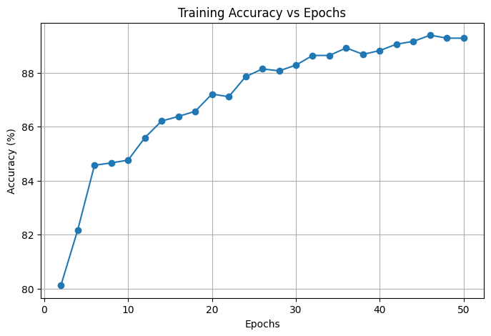

5.3 Model Evaluation
The model was evaluated using standard classification metrics.

Metrics Used:
- Top-1 Accuracy :90.33% AFTER TTA.
The achieved accuracy demonstrates that the proposed hybrid architecture effectively captures both global and fine-grained visual features. The results are competitive with existing transformer-based approaches on the dataset.

5.4 Confusion Matrix Analysis
A confusion matrix was generated to analyze class-wise performance of the model.
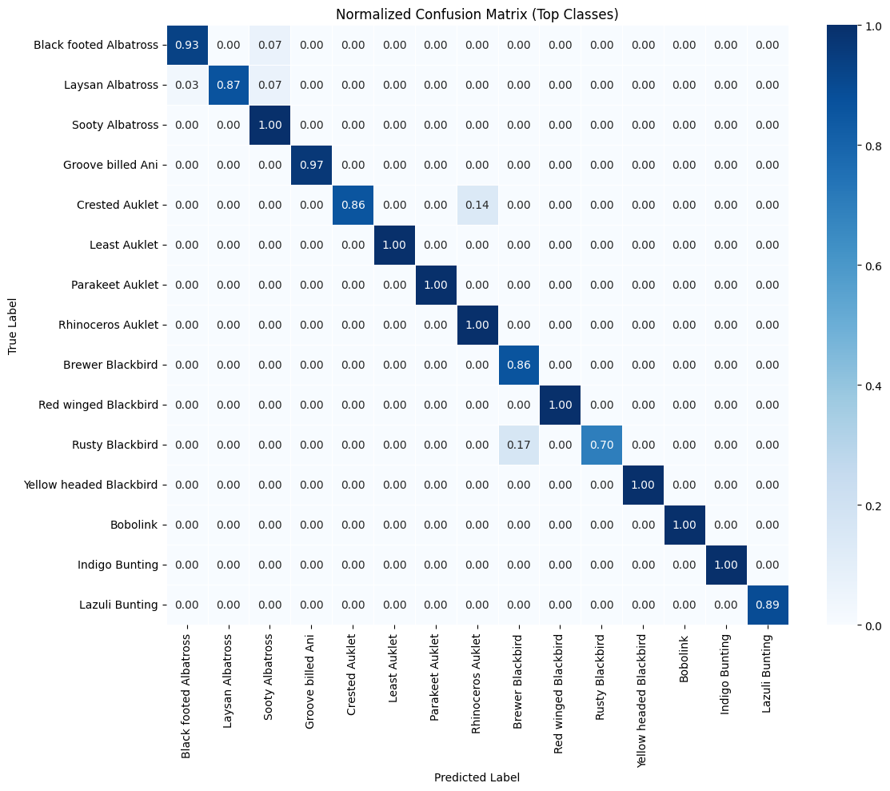

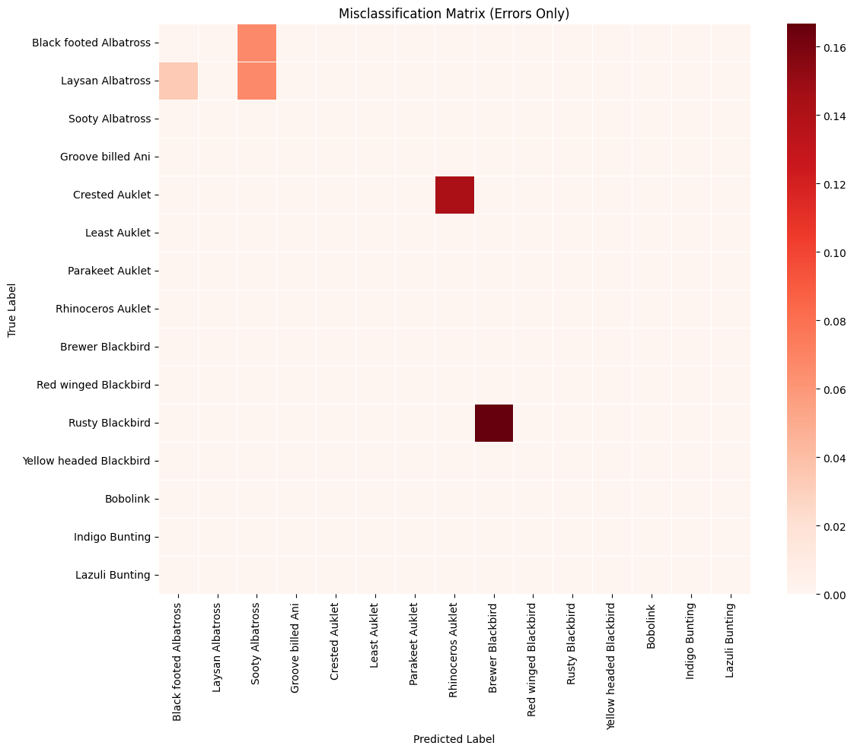

Observations:
- A strong concentration of values along the diagonal indicates correct classification for most classes
- Misclassifications primarily occur among visually similar bird species with subtle differences
- The model demonstrates strong capability in distinguishing fine-grained patterns, although some ambiguity remains in highly similar categories

5.5 Effect of Part-Based Attention
The inclusion of the part-based attention module significantly improves performance compared to the baseline Swin Transformer.

Key Observations:
- Enhanced focus on discriminative regions such as the head, wings, and tail
- Improved ability to capture subtle inter-class differences
- Reduced confusion between visually similar species
These results validate the effectiveness of learnable part tokens for fine-grained feature extraction without requiring explicit part annotations.

5.6 Grad-CAM Visualization Analysis

To further understand the decision-making process of the proposed model, Grad-CAM (Gradient-weighted Class Activation Mapping) is used to visualize the regions of the input image that contribute most to the classification.
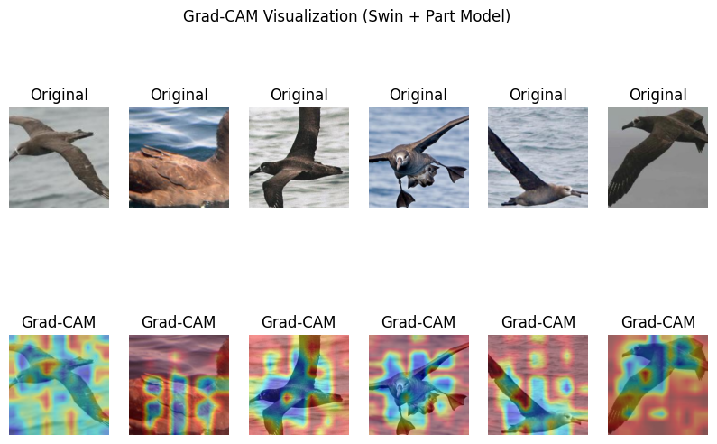

5.7 Discussion
The experimental results highlight several important insights:
- The combination of global representations from the Swin Transformer and local features from the attention module leads to improved classification performance
- Data augmentation techniques such as Mixup and CutMix contribute significantly to model generalization
- Test-Time Augmentation (TTA) enhances prediction robustness by averaging outputs from multiple augmented inputs

Limitations:
- Some visually similar species remain difficult to distinguish due to minimal feature differences
- Model performance is sensitive to image quality, pose variations, and occlusions
- The diversity constraint used is relatively simple and may not fully enforce optimal part separation

5.8 Summary
The experimental results validate the effectiveness of the proposed approach for fine-grained bird species classification. The model achieves high accuracy and demonstrates strong capability in capturing both global and local visual features.
Overall, the integration of part-based attention with a transformer backbone provides a robust and interpretable solution for fine-grained recognition tasks.

Chapter 6
Conclusion
The proposed work presents an effective and scalable solution for fine-grained bird species classification by integrating a Swin Transformer backbone with a part-based attention mechanism. The primary objective of this study was to address the challenge of distinguishing between visually similar bird species by capturing both global contextual information and subtle local discriminative features.
The Swin Transformer enables efficient hierarchical feature extraction and captures long-range dependencies within the image, while the part-based attention module enhances the model’s ability to focus on critical regions such as the head, wings, and tail. This combination allows the model to learn rich and meaningful representations without relying on explicit part annotations, making the approach both efficient and scalable.
The model was trained and evaluated on the CUB-200-2011 dataset, achieving a Top-1 accuracy of 90.33%, which demonstrates strong performance in fine-grained classification tasks. The use of advanced training strategies such as Mixup, CutMix, and cosine learning rate scheduling contributed to improved generalization and stable convergence. Furthermore, the application of Test-Time Augmentation enhanced prediction robustness during inference.
The results obtained from the confusion matrix and training curves indicate that the model effectively learns discriminative features and generalizes well to unseen data. Additionally, Grad-CAM visualizations confirm that the model focuses on semantically meaningful regions of the bird, validating the interpretability of the proposed approach.
Despite its strong performance, the model still faces challenges in distinguishing between highly similar species, particularly under variations in pose, lighting, and occlusion. However, the integration of part-based attention significantly reduces such ambiguities compared to baseline methods.
In conclusion, this work demonstrates that combining transformer-based architectures with attention-driven part modeling provides a powerful framework for fine-grained visual recognition. The proposed approach not only achieves high accuracy but also offers improved interpretability and scalability, making it a promising solution for real-world applications in wildlife monitoring and biodiversity analysis.

Chapter 7

FUTURE ENHANCEMENTS
While the proposed model achieves strong performance in fine-grained bird species classification, several enhancements can be explored to further improve its capability and applicability.

1. Integration with Object Detection Models
In real-world scenarios, input images may contain complex backgrounds or multiple objects. To address this, an object detection model such as YOLO or Faster R-CNN can be integrated to first detect and localize the bird in the image. The detected region can then be cropped and passed to the classification model for species identification.
This approach improves robustness by ensuring that the classifier focuses only on the relevant object, reducing background noise and improving prediction accuracy.

2. Improved Part-Based Feature Learning
The current part-based attention mechanism can be enhanced by incorporating more advanced techniques for better separation and localization of discriminative regions. This can further improve the model’s ability to distinguish between highly similar species.

3. Lightweight and Efficient Model Design
The proposed model can be optimized for deployment on resource-constrained devices such as mobile phones or embedded systems. Techniques such as model pruning, quantization, and knowledge distillation can be explored to reduce computational complexity.

4. Few-Shot and Zero-Shot Learning
Future work can extend the model to handle scenarios with limited training data. Few-shot or zero-shot learning approaches can enable the system to classify new or rare bird species with minimal labeled data.

5. Multi-Modal Learning
Incorporating additional data modalities such as textual descriptions, habitat information, or audio signals (bird calls) can enhance classification accuracy and robustness.

6. Advanced Attention Mechanisms
Exploring more sophisticated attention mechanisms or hybrid architectures may further improve feature representation and reduce redundancy among learned features.

7. Real-Time Deployment
The system can be extended into a real-time application for bird species identification using live camera feeds. This can be useful for wildlife monitoring, ecological research, and educational purposes.

References
- Swin Transformer: Hierarchical Vision Transformer using Shifted Windows
Liu, Z., Lin, Y., Cao, Y., Hu, H., Wei, Y., Zhang, Z., Lin, S., & Guo, B. (2021). Swin Transformer: Hierarchical Vision Transformer using Shifted Windows. Proceedings of the IEEE/CVF International Conference on Computer Vision (ICCV).
- An Image is Worth 16x16 Words: Transformers for Image Recognition at Scale
Dosovitskiy, A., Beyer, L., Kolesnikov, A., et al. (2021). An Image is Worth 16x16 Words: Transformers for Image Recognition at Scale. International Conference on Learning Representations (ICLR).
- Part-Based R-CNNs for Fine-Grained Category Detection
Zhang, N., Donahue, J., Girshick, R., & Darrell, T. (2014). Part-Based R-CNNs for Fine-Grained Category Detection. European Conference on Computer Vision (ECCV).
- CUB-200-2011 Dataset
Wah, C., Branson, S., Welinder, P., Perona, P., & Belongie, S. (2011). The Caltech-UCSD Birds-200-2011 Dataset. California Institute of Technology.
- Grad-CAM: Visual Explanations from Deep Networks via Gradient-based Localization
Selvaraju, R. R., Cogswell, M., Das, A., Vedantam, R., Parikh, D., & Batra, D. (2017). Grad-CAM: Visual Explanations from Deep Networks via Gradient-based Localization. ICCV.
- PyTorch
Paszke, A., Gross, S., Massa, F., et al. (2019). PyTorch: An Imperative Style, High-Performance Deep Learning Library. NeurIPS.
- timm (PyTorch Image Models)
Wightman, R. (2019). PyTorch Image Models (timm). GitHub Repository.

Code
Dataset Download (CUB-200-2011):
Importing Libraries:
!pip install kaggle
!pip install git+https://github.com/openai/CLIP.git
!pip install torch torchvision
Requirement already satisfied: kaggle in /usr/local/lib/python3.12/dist-packages (2.0.2)
Requirement already satisfied: bleach in /usr/local/lib/python3.12/dist-packages (from kaggle) (6.3.0)
Requirement already satisfied: jupytext in /usr/local/lib/python3.12/dist-packages (from kaggle) (1.19.1)
Requirement already satisfied: kagglesdk<1.0,>=0.1.20 in /usr/local/lib/python3.12/dist-packages (from kaggle) (0.1.20)
Requirement already satisfied: packaging in /usr/local/lib/python3.12/dist-packages (from kaggle) (26.1)
Requirement already satisfied: protobuf in /usr/local/lib/python3.12/dist-packages (from kaggle) (5.29.6)
Requirement already satisfied: python-dateutil in /usr/local/lib/python3.12/dist-packages (from kaggle) (2.9.0.post0)
Requirement already satisfied: python-slugify in /usr/local/lib/python3.12/dist-packages (from kaggle) (8.0.4)
Requirement already satisfied: requests in /usr/local/lib/python3.12/dist-packages (from kaggle) (2.32.4)
Requirement already satisfied: tqdm in /usr/local/lib/python3.12/dist-packages (from kaggle) (4.67.3)
Requirement already satisfied: urllib3>=1.15.1 in /usr/local/lib/python3.12/dist-packages (from kaggle) (2.5.0)
Requirement already satisfied: webencodings in /usr/local/lib/python3.12/dist-packages (from bleach->kaggle) (0.5.1)
Requirement already satisfied: markdown-it-py>=1.0 in /usr/local/lib/python3.12/dist-packages (from jupytext->kaggle) (4.0.0)
Requirement already satisfied: mdit-py-plugins in /usr/local/lib/python3.12/dist-packages (from jupytext->kaggle) (0.5.0)
Requirement already satisfied: nbformat in /usr/local/lib/python3.12/dist-packages (from jupytext->kaggle) (5.10.4)
Requirement already satisfied: pyyaml in /usr/local/lib/python3.12/dist-packages (from jupytext->kaggle) (6.0.3)
Requirement already satisfied: six>=1.5 in /usr/local/lib/python3.12/dist-packages (from python-dateutil->kaggle) (1.17.0)
Requirement already satisfied: text-unidecode>=1.3 in /usr/local/lib/python3.12/dist-packages (from python-slugify->kaggle) (1.3)
Requirement already satisfied: charset_normalizer<4,>=2 in /usr/local/lib/python3.12/dist-packages (from requests->kaggle) (3.4.7)
Requirement already satisfied: idna<4,>=2.5 in /usr/local/lib/python3.12/dist-packages (from requests->kaggle) (3.13)
Requirement already satisfied: certifi>=2017.4.17 in /usr/local/lib/python3.12/dist-packages (from requests->kaggle) (2026.4.22)
Requirement already satisfied: mdurl~=0.1 in /usr/local/lib/python3.12/dist-packages (from markdown-it-py>=1.0->jupytext->kaggle) (0.1.2)
Requirement already satisfied: fastjsonschema>=2.15 in /usr/local/lib/python3.12/dist-packages (from nbformat->jupytext->kaggle) (2.21.2)
Requirement already satisfied: jsonschema>=2.6 in /usr/local/lib/python3.12/dist-packages (from nbformat->jupytext->kaggle) (4.26.0)
Requirement already satisfied: jupyter-core!=5.0.*,>=4.12 in /usr/local/lib/python3.12/dist-packages (from nbformat->jupytext->kaggle) (5.9.1)
Requirement already satisfied: traitlets>=5.1 in /usr/local/lib/python3.12/dist-packages (from nbformat->jupytext->kaggle) (5.7.1)
Requirement already satisfied: attrs>=22.2.0 in /usr/local/lib/python3.12/dist-packages (from jsonschema>=2.6->nbformat->jupytext->kaggle) (26.1.0)
Requirement already satisfied: jsonschema-specifications>=2023.03.6 in /usr/local/lib/python3.12/dist-packages (from jsonschema>=2.6->nbformat->jupytext->kaggle) (2025.9.1)
Requirement already satisfied: referencing>=0.28.4 in /usr/local/lib/python3.12/dist-packages (from jsonschema>=2.6->nbformat->jupytext->kaggle) (0.37.0)
Requirement already satisfied: rpds-py>=0.25.0 in /usr/local/lib/python3.12/dist-packages (from jsonschema>=2.6->nbformat->jupytext->kaggle) (0.30.0)
Requirement already satisfied: platformdirs>=2.5 in /usr/local/lib/python3.12/dist-packages (from jupyter-core!=5.0.*,>=4.12->nbformat->jupytext->kaggle) (4.9.6)
Requirement already satisfied: typing-extensions>=4.4.0 in /usr/local/lib/python3.12/dist-packages (from referencing>=0.28.4->jsonschema>=2.6->nbformat->jupytext->kaggle) (4.15.0)
Collecting git+https://github.com/openai/CLIP.git
Cloning https://github.com/openai/CLIP.git to /tmp/pip-req-build-02pm6cg9
Running command git clone --filter=blob:none --quiet https://github.com/openai/CLIP.git /tmp/pip-req-build-02pm6cg9
Resolved https://github.com/openai/CLIP.git to commit d05afc436d78f1c48dc0dbf8e5980a9d471f35f6
Preparing metadata (setup.py) ... done
Collecting ftfy (from clip==1.0)
Downloading ftfy-6.3.1-py3-none-any.whl.metadata (7.3 kB)
Requirement already satisfied: packaging in /usr/local/lib/python3.12/dist-packages (from clip==1.0) (26.1)
Requirement already satisfied: regex in /usr/local/lib/python3.12/dist-packages (from clip==1.0) (2025.11.3)
Requirement already satisfied: tqdm in /usr/local/lib/python3.12/dist-packages (from clip==1.0) (4.67.3)
Requirement already satisfied: torch in /usr/local/lib/python3.12/dist-packages (from clip==1.0) (2.10.0+cu128)
Requirement already satisfied: torchvision in /usr/local/lib/python3.12/dist-packages (from clip==1.0) (0.25.0+cu128)
Requirement already satisfied: wcwidth in /usr/local/lib/python3.12/dist-packages (from ftfy->clip==1.0) (0.6.0)
Requirement already satisfied: filelock in /usr/local/lib/python3.12/dist-packages (from torch->clip==1.0) (3.29.0)
Requirement already satisfied: typing-extensions>=4.10.0 in /usr/local/lib/python3.12/dist-packages (from torch->clip==1.0) (4.15.0)
Requirement already satisfied: setuptools in /usr/local/lib/python3.12/dist-packages (from torch->clip==1.0) (75.2.0)
Requirement already satisfied: sympy>=1.13.3 in /usr/local/lib/python3.12/dist-packages (from torch->clip==1.0) (1.14.0)
Requirement already satisfied: networkx>=2.5.1 in /usr/local/lib/python3.12/dist-packages (from torch->clip==1.0) (3.6.1)
Requirement already satisfied: jinja2 in /usr/local/lib/python3.12/dist-packages (from torch->clip==1.0) (3.1.6)
Requirement already satisfied: fsspec>=0.8.5 in /usr/local/lib/python3.12/dist-packages (from torch->clip==1.0) (2025.3.0)
Requirement already satisfied: cuda-bindings==12.9.4 in /usr/local/lib/python3.12/dist-packages (from torch->clip==1.0) (12.9.4)
Requirement already satisfied: nvidia-cuda-nvrtc-cu12==12.8.93 in /usr/local/lib/python3.12/dist-packages (from torch->clip==1.0) (12.8.93)
Requirement already satisfied: nvidia-cuda-runtime-cu12==12.8.90 in /usr/local/lib/python3.12/dist-packages (from torch->clip==1.0) (12.8.90)
Requirement already satisfied: nvidia-cuda-cupti-cu12==12.8.90 in /usr/local/lib/python3.12/dist-packages (from torch->clip==1.0) (12.8.90)
Requirement already satisfied: nvidia-cudnn-cu12==9.10.2.21 in /usr/local/lib/python3.12/dist-packages (from torch->clip==1.0) (9.10.2.21)
Requirement already satisfied: nvidia-cublas-cu12==12.8.4.1 in /usr/local/lib/python3.12/dist-packages (from torch->clip==1.0) (12.8.4.1)
Requirement already satisfied: nvidia-cufft-cu12==11.3.3.83 in /usr/local/lib/python3.12/dist-packages (from torch->clip==1.0) (11.3.3.83)
Requirement already satisfied: nvidia-curand-cu12==10.3.9.90 in /usr/local/lib/python3.12/dist-packages (from torch->clip==1.0) (10.3.9.90)
Requirement already satisfied: nvidia-cusolver-cu12==11.7.3.90 in /usr/local/lib/python3.12/dist-packages (from torch->clip==1.0) (11.7.3.90)
Requirement already satisfied: nvidia-cusparse-cu12==12.5.8.93 in /usr/local/lib/python3.12/dist-packages (from torch->clip==1.0) (12.5.8.93)
Requirement already satisfied: nvidia-cusparselt-cu12==0.7.1 in /usr/local/lib/python3.12/dist-packages (from torch->clip==1.0) (0.7.1)
Requirement already satisfied: nvidia-nccl-cu12==2.27.5 in /usr/local/lib/python3.12/dist-packages (from torch->clip==1.0) (2.27.5)
Requirement already satisfied: nvidia-nvshmem-cu12==3.4.5 in /usr/local/lib/python3.12/dist-packages (from torch->clip==1.0) (3.4.5)
Requirement already satisfied: nvidia-nvtx-cu12==12.8.90 in /usr/local/lib/python3.12/dist-packages (from torch->clip==1.0) (12.8.90)
Requirement already satisfied: nvidia-nvjitlink-cu12==12.8.93 in /usr/local/lib/python3.12/dist-packages (from torch->clip==1.0) (12.8.93)
Requirement already satisfied: nvidia-cufile-cu12==1.13.1.3 in /usr/local/lib/python3.12/dist-packages (from torch->clip==1.0) (1.13.1.3)
Requirement already satisfied: triton==3.6.0 in /usr/local/lib/python3.12/dist-packages (from torch->clip==1.0) (3.6.0)
Requirement already satisfied: cuda-pathfinder~=1.1 in /usr/local/lib/python3.12/dist-packages (from cuda-bindings==12.9.4->torch->clip==1.0) (1.5.3)
Requirement already satisfied: numpy in /usr/local/lib/python3.12/dist-packages (from torchvision->clip==1.0) (2.0.2)
Requirement already satisfied: pillow!=8.3.*,>=5.3.0 in /usr/local/lib/python3.12/dist-packages (from torchvision->clip==1.0) (11.3.0)
Requirement already satisfied: mpmath<1.4,>=1.1.0 in /usr/local/lib/python3.12/dist-packages (from sympy>=1.13.3->torch->clip==1.0) (1.3.0)
Requirement already satisfied: MarkupSafe>=2.0 in /usr/local/lib/python3.12/dist-packages (from jinja2->torch->clip==1.0) (3.0.3)
Downloading ftfy-6.3.1-py3-none-any.whl (44 kB)
━━━━━━━━━━━━━━━━━━━━━━━━━━━━━━━━━━━━━━━━ 44.8/44.8 kB 4.2 MB/s eta 0:00:00
Building wheels for collected packages: clip
Building wheel for clip (setup.py) ... done
Created wheel for clip: filename=clip-1.0-py3-none-any.whl size=1369490 sha256=001619752c9961e9f4c1a14fb14d0f79334f88ac916047ee45aba76ccbfec5ae
Stored in directory: /tmp/pip-ephem-wheel-cache-4q_xfug3/wheels/35/3e/df/3d24cbfb3b6a06f17a2bfd7d1138900d4365d9028aa8f6e92f
Successfully built clip
Installing collected packages: ftfy, clip
Successfully installed clip-1.0 ftfy-6.3.1
Requirement already satisfied: torch in /usr/local/lib/python3.12/dist-packages (2.10.0+cu128)
Requirement already satisfied: torchvision in /usr/local/lib/python3.12/dist-packages (0.25.0+cu128)
Requirement already satisfied: filelock in /usr/local/lib/python3.12/dist-packages (from torch) (3.29.0)
Requirement already satisfied: typing-extensions>=4.10.0 in /usr/local/lib/python3.12/dist-packages (from torch) (4.15.0)
Requirement already satisfied: setuptools in /usr/local/lib/python3.12/dist-packages (from torch) (75.2.0)
Requirement already satisfied: sympy>=1.13.3 in /usr/local/lib/python3.12/dist-packages (from torch) (1.14.0)
Requirement already satisfied: networkx>=2.5.1 in /usr/local/lib/python3.12/dist-packages (from torch) (3.6.1)
Requirement already satisfied: jinja2 in /usr/local/lib/python3.12/dist-packages (from torch) (3.1.6)
Requirement already satisfied: fsspec>=0.8.5 in /usr/local/lib/python3.12/dist-packages (from torch) (2025.3.0)
Requirement already satisfied: cuda-bindings==12.9.4 in /usr/local/lib/python3.12/dist-packages (from torch) (12.9.4)
Requirement already satisfied: nvidia-cuda-nvrtc-cu12==12.8.93 in /usr/local/lib/python3.12/dist-packages (from torch) (12.8.93)
Requirement already satisfied: nvidia-cuda-runtime-cu12==12.8.90 in /usr/local/lib/python3.12/dist-packages (from torch) (12.8.90)
Requirement already satisfied: nvidia-cuda-cupti-cu12==12.8.90 in /usr/local/lib/python3.12/dist-packages (from torch) (12.8.90)
Requirement already satisfied: nvidia-cudnn-cu12==9.10.2.21 in /usr/local/lib/python3.12/dist-packages (from torch) (9.10.2.21)
Requirement already satisfied: nvidia-cublas-cu12==12.8.4.1 in /usr/local/lib/python3.12/dist-packages (from torch) (12.8.4.1)
Requirement already satisfied: nvidia-cufft-cu12==11.3.3.83 in /usr/local/lib/python3.12/dist-packages (from torch) (11.3.3.83)
Requirement already satisfied: nvidia-curand-cu12==10.3.9.90 in /usr/local/lib/python3.12/dist-packages (from torch) (10.3.9.90)
Requirement already satisfied: nvidia-cusolver-cu12==11.7.3.90 in /usr/local/lib/python3.12/dist-packages (from torch) (11.7.3.90)
Requirement already satisfied: nvidia-cusparse-cu12==12.5.8.93 in /usr/local/lib/python3.12/dist-packages (from torch) (12.5.8.93)
Requirement already satisfied: nvidia-cusparselt-cu12==0.7.1 in /usr/local/lib/python3.12/dist-packages (from torch) (0.7.1)
Requirement already satisfied: nvidia-nccl-cu12==2.27.5 in /usr/local/lib/python3.12/dist-packages (from torch) (2.27.5)
Requirement already satisfied: nvidia-nvshmem-cu12==3.4.5 in /usr/local/lib/python3.12/dist-packages (from torch) (3.4.5)
Requirement already satisfied: nvidia-nvtx-cu12==12.8.90 in /usr/local/lib/python3.12/dist-packages (from torch) (12.8.90)
Requirement already satisfied: nvidia-nvjitlink-cu12==12.8.93 in /usr/local/lib/python3.12/dist-packages (from torch) (12.8.93)
Requirement already satisfied: nvidia-cufile-cu12==1.13.1.3 in /usr/local/lib/python3.12/dist-packages (from torch) (1.13.1.3)
Requirement already satisfied: triton==3.6.0 in /usr/local/lib/python3.12/dist-packages (from torch) (3.6.0)
Requirement already satisfied: cuda-pathfinder~=1.1 in /usr/local/lib/python3.12/dist-packages (from cuda-bindings==12.9.4->torch) (1.5.3)
Requirement already satisfied: numpy in /usr/local/lib/python3.12/dist-packages (from torchvision) (2.0.2)
Requirement already satisfied: pillow!=8.3.*,>=5.3.0 in /usr/local/lib/python3.12/dist-packages (from torchvision) (11.3.0)
Requirement already satisfied: mpmath<1.4,>=1.1.0 in /usr/local/lib/python3.12/dist-packages (from sympy>=1.13.3->torch) (1.3.0)
Requirement already satisfied: MarkupSafe>=2.0 in /usr/local/lib/python3.12/dist-packages (from jinja2->torch) (3.0.3)

Dataset Overview:

!kaggle datasets download -d wenewone/cub2002011

# ===============================
# 5️⃣ Unzip Dataset
# ===============================
!unzip -q cub2002011.zip

# ===============================
# 6️⃣ Verify Structure
# ===============================
print("\n📂 Root Directory:")
!ls

print("\n📂 Inside CUB_200_2011:")
!ls CUB_200_2011

Output:
Dataset URL: https://www.kaggle.com/datasets/wenewone/cub2002011
License(s): CC0-1.0
Downloading cub2002011.zip to /content
100% 1.49G/1.49G [00:48<00:00, 33.2MB/s]

📂 Root Directory:
best_model.pth cub2002011.zip sample_data
CUB_200_2011 cvpr2016_cub segmentations

📂 Inside CUB_200_2011:
attributes image_class_labels.txt parts
bounding_boxes.txt images README
classes.txt images.txt train_test_split.txt

Cropping Images of train_test_split.txt Images from the bounding boxes.txt:

import os
import pandas as pd
from PIL import Image
from tqdm import tqdm

dataset_path = "CUB_200_2011"
images_path = os.path.join(dataset_path, "images")

# load metadata
images = pd.read_csv(
os.path.join(dataset_path, "images.txt"),
sep=" ",
names=["img_id","filepath"]
)

bbox = pd.read_csv(
os.path.join(dataset_path, "bounding_boxes.txt"),
sep=" ",
names=["img_id","x","y","width","height"]
)

split = pd.read_csv(
os.path.join(dataset_path, "train_test_split.txt"),
sep=" ",
names=["img_id","is_train"]
)

# merge all tables
data = images.merge(bbox,on="img_id").merge(split,on="img_id")

train_out = "CUB_cropped/train"
test_out = "CUB_cropped/test"

os.makedirs(train_out, exist_ok=True)
os.makedirs(test_out, exist_ok=True)

print("Cropping images...")

for _, row in tqdm(data.iterrows(), total=len(data)):

img_path = os.path.join(images_path, row.filepath)

img = Image.open(img_path).convert("RGB")

x = int(row.x)
y = int(row.y)
w = int(row.width)
h = int(row.height)

crop = img.crop((x, y, x+w, y+h))

if row.is_train == 1:
save_dir = train_out
else:
save_dir = test_out

save_path = os.path.join(save_dir, row.filepath)

os.makedirs(os.path.dirname(save_path), exist_ok=True)

crop.save(save_path)

print("Cropping completed")

Output:
Cropping images...
100%|██████████| 11788/11788 [00:50<00:00, 234.15it/s]
Cropping completed

Training the model:

SWIN + PART MODEL

# =====================================
# FINAL STABLE SWIN + PART MODEL
# =====================================

!pip install timm

import torch
import torch.nn as nn
import timm
from torchvision import transforms
from torchvision.datasets import ImageFolder
from torch.utils.data import DataLoader
from tqdm import tqdm
import torch.amp as amp
from timm.data.mixup import Mixup
from timm.loss import SoftTargetCrossEntropy
from torch.optim.lr_scheduler import SequentialLR, LinearLR, CosineAnnealingLR

device = torch.device("cuda" if torch.cuda.is_available() else "cpu")
torch.backends.cudnn.benchmark = True

# =====================================
# CONFIG
# =====================================

class CFG:
model_name = "swin_large_patch4_window12_384"
num_classes = 200
num_parts = 4
image_size = 384

stage1_epochs = 8
stage2_epochs = 42

batch_size = 16
num_workers = 4

backbone_lr = 5e-6
head_lr = 2e-4
weight_decay = 0.05

mixup_alpha = 0.8
cutmix_alpha = 1.0
label_smoothing = 0.1

train_dir = "CUB_cropped/train"
test_dir = "CUB_cropped/test"

save_path = "best_model.pth"

cfg = CFG()

# =====================================
# PART ATTENTION
# =====================================

class CrossAttentionPart(nn.Module):

def __init__(self, dim, num_parts=4):
super().__init__()
self.part_tokens = nn.Parameter(torch.randn(1, num_parts, dim))
self.attn = nn.MultiheadAttention(dim, num_heads=8, batch_first=True)

def forward(self, tokens):
B = tokens.size(0)
queries = self.part_tokens.expand(B, -1, -1)
part_feats, _ = self.attn(queries, tokens, tokens)
return part_feats

# =====================================
# MODEL
# =====================================

class SwinPartModel(nn.Module):

def __init__(self):
super().__init__()

self.backbone = timm.create_model(
cfg.model_name,
pretrained=True,
num_classes=0,
global_pool=""
)

dim = self.backbone.num_features

self.part_module = CrossAttentionPart(dim, cfg.num_parts)

self.fusion = nn.Sequential(
nn.LayerNorm(dim * (1 + cfg.num_parts)),
nn.Linear(dim * (1 + cfg.num_parts), dim),
nn.GELU(),
nn.Dropout(0.4)
)

self.classifier = nn.Linear(dim, cfg.num_classes)

def forward(self, x):

tokens = self.backbone.forward_features(x)

if tokens.dim() == 4:
B, H, W, C = tokens.shape
tokens = tokens.view(B, H * W, C)

global_feat = tokens.mean(dim=1)

part_feats = self.part_module(tokens)
part_flat = part_feats.reshape(part_feats.size(0), -1)

fused = torch.cat([global_feat, part_flat], dim=1)
fused = self.fusion(fused)

logits = self.classifier(fused)

return logits, part_feats # safe now (no compile)

model = SwinPartModel().to(device)

# =====================================
# TRANSFORMS
# =====================================

mean=[0.485,0.456,0.406]
std=[0.229,0.224,0.225]

train_tf = transforms.Compose([
transforms.RandomResizedCrop(cfg.image_size, scale=(0.6,1.0)),
transforms.RandomHorizontalFlip(),
transforms.RandAugment(num_ops=2, magnitude=9),
transforms.ToTensor(),
transforms.Normalize(mean,std),
transforms.RandomErasing(p=0.3)
])

test_tf = transforms.Compose([
transforms.Resize(int(cfg.image_size*1.15)),
transforms.CenterCrop(cfg.image_size),
transforms.ToTensor(),
transforms.Normalize(mean,std)
])

# =====================================
# DATA
# =====================================

train_dataset = ImageFolder(cfg.train_dir, transform=train_tf)
test_dataset = ImageFolder(cfg.test_dir, transform=test_tf)

train_loader = DataLoader(
train_dataset,
batch_size=cfg.batch_size,
shuffle=True,
num_workers=cfg.num_workers,
pin_memory=True,
persistent_workers=True
)

test_loader = DataLoader(
test_dataset,
batch_size=cfg.batch_size,
shuffle=False,
num_workers=cfg.num_workers,
pin_memory=True
)

# =====================================
# MIXUP
# =====================================

mixup_fn = Mixup(
mixup_alpha=cfg.mixup_alpha,
cutmix_alpha=cfg.cutmix_alpha,
prob=1.0,
switch_prob=0.5,
label_smoothing=cfg.label_smoothing,
num_classes=cfg.num_classes
)

criterion = SoftTargetCrossEntropy()

# =====================================
# OPTIMIZER
# =====================================

backbone_params=[]
head_params=[]

for name,p in model.named_parameters():
if "backbone" in name:
backbone_params.append(p)
else:
head_params.append(p)

optimizer = torch.optim.AdamW(
[
{"params":backbone_params,"lr":cfg.backbone_lr},
{"params":head_params,"lr":cfg.head_lr}
],
weight_decay=cfg.weight_decay
)

scheduler = CosineAnnealingLR(
optimizer,
T_max=cfg.stage1_epochs + cfg.stage2_epochs,
eta_min=1e-6
)

scaler = amp.GradScaler()

# =====================================
# DIVERSITY LOSS
# =====================================

def diversity_loss(parts):
B, P, C = parts.shape
parts = nn.functional.normalize(parts, dim=-1)
sim = torch.matmul(parts, parts.transpose(1,2))
loss = (sim.sum() - B * P) / (B * P * (P-1))
return loss

# =====================================
# EVALUATION
# =====================================

@torch.no_grad()
def evaluate(model, loader):

model.eval()
correct=0
total=0

for imgs,labels in loader:

imgs=imgs.to(device)
labels=labels.to(device)

with amp.autocast(device_type="cuda"):
out1,_ = model(imgs)
out2,_ = model(torch.flip(imgs,[3]))

outputs=(out1+out2)/2
_,pred=outputs.max(1)

correct+=(pred==labels).sum().item()
total+=labels.size(0)

return 100*correct/total

# =====================================
# TRAIN LOOP
# =====================================

best_acc=0
patience=6
no_improve=0

total_epochs = cfg.stage1_epochs + cfg.stage2_epochs

for epoch in range(total_epochs):

model.train()
running_loss=0

for imgs,labels in tqdm(train_loader):

imgs=imgs.to(device)
labels=labels.to(device)

imgs,labels=mixup_fn(imgs,labels)

optimizer.zero_grad()

with amp.autocast(device_type="cuda"):
logits, parts = model(imgs)
cls_loss = criterion(logits,labels)
div_loss = diversity_loss(parts)
loss = cls_loss + 0.05 * div_loss

scaler.scale(loss).backward()
scaler.step(optimizer)
scaler.update()

running_loss+=loss.item()

scheduler.step()

# evaluate every 2 epochs
if (epoch+1)%2==0:
val_acc = evaluate(model,test_loader)

print(f"Epoch {epoch+1} | Acc {val_acc:.2f}")

if val_acc>best_acc:
best_acc=val_acc
no_improve=0
torch.save(model.state_dict(),cfg.save_path)
else:
no_improve+=1

if no_improve>=patience:
print("Early stopping")
break

print("Best Accuracy:",best_acc)

Output:

Requirement already satisfied: timm in /usr/local/lib/python3.12/dist-packages (1.0.26)
Requirement already satisfied: torch in /usr/local/lib/python3.12/dist-packages (from timm) (2.10.0+cu128)
Requirement already satisfied: torchvision in /usr/local/lib/python3.12/dist-packages (from timm) (0.25.0+cu128)
Requirement already satisfied: pyyaml in /usr/local/lib/python3.12/dist-packages (from timm) (6.0.3)
Requirement already satisfied: huggingface_hub in /usr/local/lib/python3.12/dist-packages (from timm) (1.10.1)
Requirement already satisfied: safetensors in /usr/local/lib/python3.12/dist-packages (from timm) (0.7.0)
Requirement already satisfied: filelock>=3.10.0 in /usr/local/lib/python3.12/dist-packages (from huggingface_hub->timm) (3.25.2)
Requirement already satisfied: fsspec>=2023.5.0 in /usr/local/lib/python3.12/dist-packages (from huggingface_hub->timm) (2025.3.0)
Requirement already satisfied: hf-xet<2.0.0,>=1.4.3 in /usr/local/lib/python3.12/dist-packages (from huggingface_hub->timm) (1.4.3)
Requirement already satisfied: httpx<1,>=0.23.0 in /usr/local/lib/python3.12/dist-packages (from huggingface_hub->timm) (0.28.1)
Requirement already satisfied: packaging>=20.9 in /usr/local/lib/python3.12/dist-packages (from huggingface_hub->timm) (26.0)
Requirement already satisfied: tqdm>=4.42.1 in /usr/local/lib/python3.12/dist-packages (from huggingface_hub->timm) (4.67.3)
Requirement already satisfied: typer in /usr/local/lib/python3.12/dist-packages (from huggingface_hub->timm) (0.24.1)
Requirement already satisfied: typing-extensions>=4.1.0 in /usr/local/lib/python3.12/dist-packages (from huggingface_hub->timm) (4.15.0)
Requirement already satisfied: setuptools in /usr/local/lib/python3.12/dist-packages (from torch->timm) (75.2.0)
Requirement already satisfied: sympy>=1.13.3 in /usr/local/lib/python3.12/dist-packages (from torch->timm) (1.14.0)
Requirement already satisfied: networkx>=2.5.1 in /usr/local/lib/python3.12/dist-packages (from torch->timm) (3.6.1)
Requirement already satisfied: jinja2 in /usr/local/lib/python3.12/dist-packages (from torch->timm) (3.1.6)
Requirement already satisfied: cuda-bindings==12.9.4 in /usr/local/lib/python3.12/dist-packages (from torch->timm) (12.9.4)
Requirement already satisfied: nvidia-cuda-nvrtc-cu12==12.8.93 in /usr/local/lib/python3.12/dist-packages (from torch->timm) (12.8.93)
Requirement already satisfied: nvidia-cuda-runtime-cu12==12.8.90 in /usr/local/lib/python3.12/dist-packages (from torch->timm) (12.8.90)
Requirement already satisfied: nvidia-cuda-cupti-cu12==12.8.90 in /usr/local/lib/python3.12/dist-packages (from torch->timm) (12.8.90)
Requirement already satisfied: nvidia-cudnn-cu12==9.10.2.21 in /usr/local/lib/python3.12/dist-packages (from torch->timm) (9.10.2.21)
Requirement already satisfied: nvidia-cublas-cu12==12.8.4.1 in /usr/local/lib/python3.12/dist-packages (from torch->timm) (12.8.4.1)
Requirement already satisfied: nvidia-cufft-cu12==11.3.3.83 in /usr/local/lib/python3.12/dist-packages (from torch->timm) (11.3.3.83)
Requirement already satisfied: nvidia-curand-cu12==10.3.9.90 in /usr/local/lib/python3.12/dist-packages (from torch->timm) (10.3.9.90)
Requirement already satisfied: nvidia-cusolver-cu12==11.7.3.90 in /usr/local/lib/python3.12/dist-packages (from torch->timm) (11.7.3.90)
Requirement already satisfied: nvidia-cusparse-cu12==12.5.8.93 in /usr/local/lib/python3.12/dist-packages (from torch->timm) (12.5.8.93)
Requirement already satisfied: nvidia-cusparselt-cu12==0.7.1 in /usr/local/lib/python3.12/dist-packages (from torch->timm) (0.7.1)
Requirement already satisfied: nvidia-nccl-cu12==2.27.5 in /usr/local/lib/python3.12/dist-packages (from torch->timm) (2.27.5)
Requirement already satisfied: nvidia-nvshmem-cu12==3.4.5 in /usr/local/lib/python3.12/dist-packages (from torch->timm) (3.4.5)
Requirement already satisfied: nvidia-nvtx-cu12==12.8.90 in /usr/local/lib/python3.12/dist-packages (from torch->timm) (12.8.90)
Requirement already satisfied: nvidia-nvjitlink-cu12==12.8.93 in /usr/local/lib/python3.12/dist-packages (from torch->timm) (12.8.93)
Requirement already satisfied: nvidia-cufile-cu12==1.13.1.3 in /usr/local/lib/python3.12/dist-packages (from torch->timm) (1.13.1.3)
Requirement already satisfied: triton==3.6.0 in /usr/local/lib/python3.12/dist-packages (from torch->timm) (3.6.0)
Requirement already satisfied: cuda-pathfinder~=1.1 in /usr/local/lib/python3.12/dist-packages (from cuda-bindings==12.9.4->torch->timm) (1.5.2)
Requirement already satisfied: numpy in /usr/local/lib/python3.12/dist-packages (from torchvision->timm) (2.0.2)
Requirement already satisfied: pillow!=8.3.*,>=5.3.0 in /usr/local/lib/python3.12/dist-packages (from torchvision->timm) (11.3.0)
Requirement already satisfied: anyio in /usr/local/lib/python3.12/dist-packages (from httpx<1,>=0.23.0->huggingface_hub->timm) (4.13.0)
Requirement already satisfied: certifi in /usr/local/lib/python3.12/dist-packages (from httpx<1,>=0.23.0->huggingface_hub->timm) (2026.2.25)
Requirement already satisfied: httpcore==1.* in /usr/local/lib/python3.12/dist-packages (from httpx<1,>=0.23.0->huggingface_hub->timm) (1.0.9)
Requirement already satisfied: idna in /usr/local/lib/python3.12/dist-packages (from httpx<1,>=0.23.0->huggingface_hub->timm) (3.11)
Requirement already satisfied: h11>=0.16 in /usr/local/lib/python3.12/dist-packages (from httpcore==1.*->httpx<1,>=0.23.0->huggingface_hub->timm) (0.16.0)
Requirement already satisfied: mpmath<1.4,>=1.1.0 in /usr/local/lib/python3.12/dist-packages (from sympy>=1.13.3->torch->timm) (1.3.0)
Requirement already satisfied: MarkupSafe>=2.0 in /usr/local/lib/python3.12/dist-packages (from jinja2->torch->timm) (3.0.3)
Requirement already satisfied: click>=8.2.1 in /usr/local/lib/python3.12/dist-packages (from typer->huggingface_hub->timm) (8.3.2)
Requirement already satisfied: shellingham>=1.3.0 in /usr/local/lib/python3.12/dist-packages (from typer->huggingface_hub->timm) (1.5.4)
Requirement already satisfied: rich>=12.3.0 in /usr/local/lib/python3.12/dist-packages (from typer->huggingface_hub->timm) (13.9.4)
Requirement already satisfied: annotated-doc>=0.0.2 in /usr/local/lib/python3.12/dist-packages (from typer->huggingface_hub->timm) (0.0.4)
Requirement already satisfied: markdown-it-py>=2.2.0 in /usr/local/lib/python3.12/dist-packages (from rich>=12.3.0->typer->huggingface_hub->timm) (4.0.0)
Requirement already satisfied: pygments<3.0.0,>=2.13.0 in /usr/local/lib/python3.12/dist-packages (from rich>=12.3.0->typer->huggingface_hub->timm) (2.20.0)
Requirement already satisfied: mdurl~=0.1 in /usr/local/lib/python3.12/dist-packages (from markdown-it-py>=2.2.0->rich>=12.3.0->typer->huggingface_hub->timm) (0.1.2)
/usr/local/lib/python3.12/dist-packages/huggingface_hub/utils/_auth.py:93: UserWarning:
The secret `HF_TOKEN` does not exist in your Colab secrets.
To authenticate with the Hugging Face Hub, create a token in your settings tab (https://huggingface.co/settings/tokens), set it as secret in your Google Colab and restart your session.
You will be able to reuse this secret in all of your notebooks.
Please note that authentication is recommended but still optional to access public models or datasets.
warnings.warn(
model.safetensors: 100%
801M/801M [00:05<00:00, 341MB/s]
100%|██████████| 375/375 [01:25<00:00, 4.40it/s]
100%|██████████| 375/375 [01:22<00:00, 4.54it/s]
Epoch 2 | Acc 80.12
100%|██████████| 375/375 [01:22<00:00, 4.53it/s]
100%|██████████| 375/375 [01:22<00:00, 4.54it/s]
Epoch 4 | Acc 82.17
100%|██████████| 375/375 [01:22<00:00, 4.54it/s]
100%|██████████| 375/375 [01:22<00:00, 4.53it/s]
Epoch 6 | Acc 84.57
100%|██████████| 375/375 [01:22<00:00, 4.54it/s]
100%|██████████| 375/375 [01:22<00:00, 4.54it/s]
Epoch 8 | Acc 84.66
100%|██████████| 375/375 [01:22<00:00, 4.54it/s]
100%|██████████| 375/375 [01:22<00:00, 4.54it/s]
Epoch 10 | Acc 84.76
100%|██████████| 375/375 [01:22<00:00, 4.54it/s]
100%|██████████| 375/375 [01:22<00:00, 4.54it/s]
Epoch 12 | Acc 85.59
100%|██████████| 375/375 [01:22<00:00, 4.54it/s]
100%|██████████| 375/375 [01:22<00:00, 4.54it/s]
Epoch 14 | Acc 86.21
100%|██████████| 375/375 [01:22<00:00, 4.54it/s]
100%|██████████| 375/375 [01:22<00:00, 4.54it/s]
Epoch 16 | Acc 86.38
100%|██████████| 375/375 [01:22<00:00, 4.54it/s]
100%|██████████| 375/375 [01:22<00:00, 4.54it/s]
Epoch 18 | Acc 86.57
100%|██████████| 375/375 [01:22<00:00, 4.54it/s]
100%|██████████| 375/375 [01:22<00:00, 4.54it/s]
Epoch 20 | Acc 87.21
100%|██████████| 375/375 [01:22<00:00, 4.54it/s]
100%|██████████| 375/375 [01:22<00:00, 4.54it/s]
Epoch 22 | Acc 87.11
100%|██████████| 375/375 [01:22<00:00, 4.54it/s]
100%|██████████| 375/375 [01:22<00:00, 4.54it/s]
Epoch 24 | Acc 87.85
100%|██████████| 375/375 [01:22<00:00, 4.54it/s]
100%|██████████| 375/375 [01:22<00:00, 4.54it/s]
Epoch 26 | Acc 88.14
100%|██████████| 375/375 [01:22<00:00, 4.54it/s]
100%|██████████| 375/375 [01:22<00:00, 4.54it/s]
Epoch 28 | Acc 88.07
100%|██████████| 375/375 [01:22<00:00, 4.54it/s]
100%|██████████| 375/375 [01:22<00:00, 4.54it/s]
Epoch 30 | Acc 88.28
100%|██████████| 375/375 [01:22<00:00, 4.54it/s]
100%|██████████| 375/375 [01:22<00:00, 4.53it/s]
Epoch 32 | Acc 88.64
100%|██████████| 375/375 [01:22<00:00, 4.53it/s]
100%|██████████| 375/375 [01:22<00:00, 4.54it/s]
Epoch 34 | Acc 88.64
100%|██████████| 375/375 [01:22<00:00, 4.54it/s]
100%|██████████| 375/375 [01:22<00:00, 4.54it/s]
Epoch 36 | Acc 88.92
100%|██████████| 375/375 [01:22<00:00, 4.54it/s]
100%|██████████| 375/375 [01:22<00:00, 4.53it/s]
Epoch 38 | Acc 88.68
100%|██████████| 375/375 [01:22<00:00, 4.53it/s]
100%|██████████| 375/375 [01:22<00:00, 4.53it/s]
Epoch 40 | Acc 88.82
100%|██████████| 375/375 [01:22<00:00, 4.53it/s]
100%|██████████| 375/375 [01:22<00:00, 4.54it/s]
Epoch 42 | Acc 89.06
100%|██████████| 375/375 [01:22<00:00, 4.54it/s]
100%|██████████| 375/375 [01:22<00:00, 4.54it/s]
Epoch 44 | Acc 89.16
100%|██████████| 375/375 [01:22<00:00, 4.53it/s]
100%|██████████| 375/375 [01:22<00:00, 4.53it/s]
Epoch 46 | Acc 89.39
100%|██████████| 375/375 [01:22<00:00, 4.53it/s]
100%|██████████| 375/375 [01:22<00:00, 4.54it/s]
Epoch 48 | Acc 89.28
100%|██████████| 375/375 [01:22<00:00, 4.54it/s]
100%|██████████| 375/375 [01:22<00:00, 4.54it/s]
Epoch 50 | Acc 89.28
Best Accuracy: 89.38557128063513

This is model trained accuracy of 89.38%.

After using TTA method:
# =====================================
# FINAL SAFE TTA (SWIN 384 COMPATIBLE)
# =====================================

import torch
import torch.nn as nn
import timm
from torchvision import transforms
from torchvision.datasets import ImageFolder
from torch.utils.data import DataLoader
from tqdm import tqdm
import torch.amp as amp

device = torch.device("cuda" if torch.cuda.is_available() else "cpu")

# =====================================
# MODEL (same as training)
# =====================================

class CrossAttentionPart(nn.Module):
def __init__(self, dim, num_parts=4):
super().__init__()
self.part_tokens = nn.Parameter(torch.randn(1, num_parts, dim))
self.attn = nn.MultiheadAttention(dim, num_heads=8, batch_first=True)

def forward(self, tokens):
B = tokens.size(0)
queries = self.part_tokens.expand(B, -1, -1)
part_feats, _ = self.attn(queries, tokens, tokens)
return part_feats

class SwinPartModel(nn.Module):
def __init__(self):
super().__init__()

self.backbone = timm.create_model(
"swin_large_patch4_window12_384",
pretrained=False,
num_classes=0,
global_pool=""
)

dim = self.backbone.num_features

self.part_module = CrossAttentionPart(dim, 4)

self.fusion = nn.Sequential(
nn.LayerNorm(dim * 5),
nn.Linear(dim * 5, dim),
nn.GELU(),
nn.Dropout(0.4)
)

self.classifier = nn.Linear(dim, 200)

def forward(self, x):

tokens = self.backbone.forward_features(x)

if tokens.dim() == 4:
B, H, W, C = tokens.shape
tokens = tokens.view(B, H * W, C)

global_feat = tokens.mean(dim=1)
part_feats = self.part_module(tokens)
part_flat = part_feats.reshape(part_feats.size(0), -1)

fused = torch.cat([global_feat, part_flat], dim=1)
fused = self.fusion(fused)

return self.classifier(fused)

# =====================================
# LOAD MODEL
# =====================================

model = SwinPartModel().to(device)
model.load_state_dict(torch.load("best_model.pth"))
model.eval()

print("✅ Model Loaded")

# =====================================
# TRANSFORM (CRITICAL FIX)
# =====================================

test_tf = transforms.Compose([
transforms.Resize(384), # keep ratio
transforms.CenterCrop(384), # FORCE EXACT SIZE
transforms.ToTensor(),
transforms.Normalize(
[0.485,0.456,0.406],
[0.229,0.224,0.225]
)
])

# =====================================
# DATA
# =====================================

test_dataset = ImageFolder("CUB_cropped/test", transform=test_tf)

test_loader = DataLoader(
test_dataset,
batch_size=16,
shuffle=False,
num_workers=2,
pin_memory=True
)

# =====================================
# SAFE TTA (NO SIZE ERRORS)
# =====================================

@torch.no_grad()
def evaluate_tta(model, loader):

correct = 0
total = 0

for imgs, labels in tqdm(loader):

imgs = imgs.to(device)
labels = labels.to(device)

with amp.autocast(device_type="cuda"):

# 1️⃣ Original
out1 = model(imgs)

# 2️⃣ Horizontal Flip
out2 = model(torch.flip(imgs, dims=[3]))

# 3️⃣ Slight Shift (still 384 safe)
out3 = model(torch.roll(imgs, shifts=5, dims=2))

outputs = (out1 + out2 + out3) / 3

_, preds = outputs.max(1)

correct += (preds == labels).sum().item()
total += labels.size(0)

return 100 * correct / total

# =====================================
# RUN
# =====================================

acc = evaluate_tta(model, test_loader)

print(f"\n🔥 FINAL TTA ACCURACY: {acc:.2f}%")

Output:
✅ Model Loaded
100%|██████████| 363/363 [09:38<00:00, 1.59s/it]
🔥 FINAL TTA ACCURACY: 90.35%

After using TTA method we got 90.35% accuracy and model is saved.

BIODATA

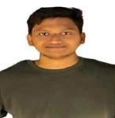
Name :K.Nichal haas Mobile Number : 9515546599
E-mail :nichal.22bce9651@vitapstudent.ac.in Permanent Address : Khammam


Name :P.Sumanth
Mobile Number : 7386618546
E-mail :sumanth.22bce7360@vitapstudent.ac.in
Permanent Address :kadapa


Name :Devansh Chhibber Mobile Number :9654059370
E-mail :devansh.22bce7919@vitapstudent.ac.in Permanent Address : Ghaziabad

